PATHOLOGY & CYTOLOGY LABORATORIES



SPECIMEN COLLECTION MANUAL

2021

This page is intentionally left blank

TABLE OF CONTENTS
Introduction and Staff 1
Insurance Affiliations 2
General Policies 6
Specimen Acceptance 6
Specimen Rejection 6
Supplies Provided by PCL (Ordering) 8
Pap Supplies 8
Non-Gyn Supplies 9
Tissue Supplies 9
Hospital Tissue Supplies 9
Procedure for Mailing Specimens to PCL 11
Gynecological Pap Smears 14
Cytology Requisition Forms 14
Fixative 15
Specimen Labeling 16
Diagnostic Pap vs Routine Pap 17
Method of Collection (ThinPrep Pap) 22
HPV Testing 26
HPV reflex testing with the ThinPrep Pap 26
HPV testing on Tissue Specimens 27
Chlamydia trachomatis and Neisseria gonorrhea Screening 29
Herpes Simplex Virus Screening 30
Vaginitis Panel Screening 31
Vaginosis Testing from Thin Prep or OneSwab 32
Group B Strep……………………………………………………………………………33

Non-Gyn Specimen Collection 35
Cytology Requisition Forms 35
Non-Gyn Fixative 36
Specimen Labeling 37
Bronchial Washings 38
Bronchial Brushings 38
Sputum …………………………………………………………… 41
Body Cavity Fluids for Cytology (Pleural, Pelvic, Peritoneal 44
Body Cavity Fluids for Crystals 45
Urinary Tract (Urine, Bladder, Prostate Secretions) 46
Gastrointestinal Tract 49
Cerebrospinal Fluids 51
Nipple Secretions 52
Breast Fine Needle Aspirations 52
Fine Needle Aspiration Quick Reference 53
Fine Needle Aspiration (General) 56
Buccal Smears for Sex Chromatin Positive (Barr) Bodies 58
Zanck Smears and Other Miscellaneous Specimens 60
Cytopathology Quality Assurance 60
Surgical Pathology 62
Specimen Identification 63
Fixation 63
Routine Tissue 63
Transportation 63
Specimen Acceptance 64
Specimen Rejection 64
Kidney and Bladder Stones 65
Routine Tissue Specimens 66
Radiographs 67
Placenta (Chromosome Analysis) 68
Tissue for Gout (Urate Crystals) 68
Lymph Nodes 69
Bone Marrow Biopsies and Aspirations 71
Muscle and Peripheral Nerve Biopsies 72
Electron Microscopy 73
Autopsies 74
Frozen Tissue Sections 75
Amputated Limbs 76
Covid-19 Testing by PCR………………………………………………………………..78
Addenda 80
Addendum A (Cytology Request Form)…………………………………………………81
Addendum B (Patient Information Sheet 82
Addendum C (Follow Up Letter) 83
Addendum D (Histology/NonGyn Request Form……………………………………….84
Addendum E (Frozen Section Consultation) 85
Addendum F (Permit For Dispotal of Anatomical Part) 86
Addendum G (Hematology Blood Smear Form)………………………………………...87
Addendum H (Placental Information Form) 88
Addendum I (UL Skeletal Muscle & Peripheral Nerve Forms) 89
Addendum J (Receipt, Release & Indemnity Agreement Form)………………………...90
Addendum K (Breast Specimen Request Form)…………………………………………91

Material Safety Data Sheets (MSDS) 93

INTRODUCTION

Pathology & Cytology Laboratories, Inc., and Chipps, Caffrey & Dubilier, P.S.C. are specialists in Anatomical Pathology, Cytopathology, Clinical Laboratory Consultations and Medical Directorships.

Founded in 1967 and located at 290 Big Run Road, Lexington, Kentucky, Pathology & Cytology Laboratories, Inc. provides the highest quality service and professional expertise, to private physicians, clinics and hospitals.

ACCREDITED & INSPECTED BY:

The American Society of Cytology
College of American Pathologists - Laboratory #16212-01
Commonwealth of Kentucky, Cabinet for Health Services - License #200072
U.S. Department of Health and Human Services Health Care Financing Administration
CLIA # 18D0648508

STAFF

- 19 Board Certified Pathologists
Daron G. Davis, M.D.
Cynthia Forker, M.D.
Richard L. Lozano, M.D.
John F. Jansen, M.D.
Patrick C. Crowe, M.D.
Fred L. Picklesimer Jr, M.D.
Jason A. Clark, M.D.
Christine A. Meece, M.D.
Alexander Castiello, M.D.
Brian Klazynski, M.D.
Edward J. Tanous, M.D.
Ana L. W. Watts, M.D.
Jessica Howard, D.O.
Jason Mull, M.D.
Harty Ashby, D.O.
George Kim, M.D.
Bradley Gibson, M.D.
Sarah Williams, M.D.
Justin Sedlak, M.D.
Keith Henry, M.D.
Douglas Damm, D.D.S.
Craig Fowler, D.D.S.

- ASCP Registered Histotechnologists
- ASCP Registered Cytotechnologists
- Qualified Staff of Medical Transcriptionists
- ASCP Registered Consulting Medical Technologists available upon request for:
- Continuing Education
- Seminars, In-service programs
- Mock laboratory inspections - to aid laboratories in their preparations for:
  - CAP inspection
  - JCAHO inspection
  - Medicare/State inspection
- Client Service Personnel Available To:
- Answer client questions related to technical procedures and laboratory services
- Maintain a library of audio-visual programs on current pertinent laboratory subjects. These programs are available to clients on a loan basis.

CLIENT BENEFITS

- PCL provides supplies for the collection and transportation of specimens at no charge to the client
- PCL returns reports by courier, mail, internet or direct interface with client Electronic Medical Records.

INSURANCE AFFILIATIONS

- PCL is a participating provider with the following insurance carriers as well as others not listed:

- Medicare
- Medicaid (KY, WV, VA, OH)
- Anthem Blue Cross Blue Shield (All Plans)
- Humana (All Plans)
- Healthstar (PPO Next)
- Commonwealth Health Alliance - HMO/PPO
- Aetna
- Champus (Tricare)
- United Mine Workers
- KY Physicians Care
- Alternative Health GE Health Care
- Cigna
- TPN Contracts (The Physicians Network)
- Cumberland Health Care
- United Health Care
- Bluegrass Family Health
- Passport
- Private Healthcare Systems (PHCS)
- Community Care Network (CCN)
- The Initial Group
- First Health
- Norton One (OMCA)

CONTACT INFORMATION

Prompt communication insures the satisfaction of our clients and the well-being of our patients.

Telephone: (859) 278-9513
KY Toll Free: (800) 264-0514
Customer Service: (859) 685-0609
Pickup/Supply Requests: (859) 685-0617
FAX number: (859) 277-6063
WEB: www.pandclab.com

Results Portal: https://portal.pclky.com

This page is intentionally left blank

GENERAL

POLICIES

GENERAL POLICIES

IMPORTANCE OF A GOOD SAMPLE
The manner in which specimens for cytology and histology are collected and handled is critical for valid results. It is therefore important that those responsible for collecting specimens be thoroughly familiar with the specific instructions for the proper collection and handling of specimens.

AUTHORIZED SOURCES
Pathology and Cytology Laboratories will accept specimens from authorized sources only (persons authorized by law to collect specimens and use medical knowledge).

BASIC CRITERIA FOR ACCEPTANCE
Every specimen received in the laboratory must meet basic criteria. These include:
- Proper labeling which includes 2 forms of patient identification on each specimen container along with specimen source
- Proper fixation
- Patient demographics/billing information
- Pertinent clinical information

- A specimen cannot be processed if the following information is not included on the requisition form. The specimen will be pulled and your office will be called for the necessary information.
- Same name on specimen and requisition form
- Patient Date of Birth
- Social Security Number
- Date of collection or Date of Service
- Source of Specimen
- Billing Information
- Last Menstrual Period for gynecological specimens

Refer to sample Cytology Request Form (Addendum A) and Tissue Request Form (Addendum D) in addendum of this manual.

REJECTION OF SPECIMENS
Every effort will be made to process a specimen as received but the following situations will make the specimen unacceptable or suboptimal:
- Unlabeled slides or specimens
- Name on slide/specimen and request do not match
- Slides broken beyond repair
- Requisitions received with no slides or specimen
- Specimen or slides received with no requisition
- Acellular smears
- Thick smears
- Bloody smears
- Inflamed smears
- Tissue and non-genital cytology specimens not received in proper fixative
- Any case not accompanied by pertinent clinical data is considered suboptimal for evaluation
- Specimen submitted by an unauthorized source

Specimens considered to be unacceptable, by recommended guidelines, for making a diagnosis will be reported to the proper authority with an explanation for rejection.

BILLING INFORMATION -
The patient’s address must be included on all requisitions. If you would like PCL to bill insurance for the test requested, please include a copy of the patient’s current insurance card (both sides of card) or complete the insurance section of the requisition. You must include the insurance company name and address, subscriber name, and subscriber policy number and group number.

Medicare will cover one routine screening pap smear every 2 years. A “screening pap smear” is one that is referred to the laboratory with no suspicion of current atypia, or the patient has no previous history of atypical findings. A copy of a signed Advanced Beneficiary Notice must accompany the pap smear if the patient has had a screening pap smear within the last 3 years. You may use the ABN form which is printed on the back of the cytology requisition. Padded copies of the forms are also available and may be obtained by calling the Client Service Department at PCL or by writing ABN on your red supply request card. It is the responsibility of the Physician to obtain this waiver and explain to the patient that Medicare may not pay for the pap smear. If Medicare denies the claim and there is not a signed ABN submitted with the pap requisition, PCL cannot bill the patient for this test. If Medicare denies the claim and there is not a signed waiver, as a penalty, an assessment will be billed to the physician account. If a patient has Medicare and Medicaid or any other secondary insurance, a signed ABN is still required.

REPORTING
Gynecological
Pap smears are reported in descriptive terminology, along with recommended follow-up, in the Bethesda System 2001 format. This allows for a more consistent reporting system from laboratory to laboratory. Pap smear slides can be requested for review or to obtain a consulting diagnosis. PCL will provide a consulting report on slides from other laboratories upon request by the client. (Call Client Services for procedure.)
Non-Gynecological
All non-gynecological cytology smears are read and reported by a pathologist. Most of these specimens will be processed and reported on the date of specimen receipt. Specimens requiring a cell block procedure will be read and reported the day following receipt of the specimen.
Histological
- Our Board Certified Pathologists are responsible for the gross and microscopic examination of specimens submitted and follow all standards dictated by the Health Care Financing Administration.
- Final reports are generated by the pathologist on the day following the gross examination of the specimen.
- In cases where decalcification or special examination is required an additional 24 hours is needed.
- There is continuous monitoring of results from frozen sections and surgical cases.
- Consultation and correlation of surgical cases from other institutions will be performed on request.
- In situ hybridization studies for papilloma virus subtypes are available upon request.

FIXATIVES
Immediate fixation of material is an essential first step for accurate interpretation. It cannot be overemphasized that improperly fixed samples may result in inaccurate diagnosis. For specific information regarding the proper fixative for a specimen, consult the genital cytology, non-genital cytology or histology sections of this manual.

SUPPLIES PROVIDED BY PCL
Supplies are provided for the collection and transportation of Pap smear and tissue specimens into our laboratory. Supplies are to be ordered by completing the PCL “Supply Request” form and sending it to PCL via the same method you use for sending specimens to the lab (mail or courier). If you cannot find a supply form, you can telephone your order by calling 859-278-9513 or 1-800-264-0514 and asking for the mail room or customer service.

When you receive supplies from PCL, included with them will be a “Supply Request” form with your name and address stamped in the left hand corner. If any of the information is not correct, please contact Client Services and we will make the correction. You will notice that the lines marked “ordered by” and “date” located in the right hand corner of the card are left blank. THE PERSON ORDERING THE SUPPLIES IS TO PUT THEIR NAME AND THE DATE ON THESE LINES. This will give us a person to contact if we have a question regarding the supplies being ordered.

Pap Supplies:
- ThinPrep Vials: Vials of liquid fixative for collection of Pap using ThinPrep method of slide preparation.
- Collection Devices: Be sure to circle the collection device you use whenever you order the ThinPrep vials. The choice of collection device is the broom or the brush/scraper. Be sure to circle the type of collection device you want on the red supply card.

Non-GYN Supplies:
These supplies are used for the collection of non-genital specimens such as FNA specimens and fluids for cytology.

- Tubes with Cytology Fixative: Individual conical shaped plastic tubes with Cytolyte fixative.

Forms:
  - Cytology Forms: Red and white requisition form to use for Pap smears.

  - Tissue Request Forms Non/GYN: Yellow requisition form to use for all tissues and bone marrow specimens, FNA specimens and fluids for cytology

Boxes:
- Large or Small Boxes

Tissue Supplies:
- 1 oz biopsy bottles: 1 oz bottle filled with 10% buffered formalin for use on small tissue specimens removed in the physician’s office
- LEEP cassettes: Plastic tissue cassettes to use for cervical/endocervical biopsies collected using the LEEP procedure.
- 2 oz biopsy bottles: 2 oz biopsy bottles filled with 10% buffered formalin to hold the LEEP cassettes
- RPMI Tissue Media is to be used whenever flow cytometry is requested on lymph node biopsy

Hospital Tissue Supplies: These supplies are for use by hospitals only.
- WhirlPak Bags: Bags with a WhirlPak closure system to use for tissue specimens. (4 oz, 18 oz or 24 oz)
- Specimen Buckets: Plastic buckets and lids for transportation of large tissue specimens removed in surgery. (16 oz, 32 oz, 86 oz or 190 oz)
- PCL Transport Bags: There are Ziploc bags labeled with the name and address of Pathology & Cytology Laboratories. The bag also contains the proper biohazard labels. The bags are to be used for courier transport of paps and tissue specimens to PCL.
  - Large Bags: A 10" by 12" Ziploc bag to use when sending in 4 or more Pap smears.
  - Small Bags: A smaller Ziploc bag to use when sending in 3 or less Pap smears. Also, these bags are to be used for all tissue specimens being sent via courier to PCL. Use one bag for each patient. Multiple tissue specimens on a patient are to be put in the same small transport bag.

Mailing Supplies: These supplies are for use by clients who mail specimens to PCL.
    - Plastic Slide Containers: Rigid plastic slide holder which protects the slide during transportation through the mail.
    - Pre-addressed Postage-Paid Envelopes: White envelopes to use for mailing the plastic slide holders containing Pap slides.
    - Biopsy Bottle Mailing Container: Pre-addressed cardboard cylinder for use in mailing biopsy bottles or Thin Prep vials.

Miscellaneous Supplies:
- Patient Information Regarding Pap Smear Tests: This is an information form that can be given to each woman having a Pap smear. It provides information regarding when to have a Pap smear and factors that can interfere with the collection and testing process.
- HPV, Chlamydia and Trichomonas patient information sheets: These are supplied in both English and Spanish. Please indicate your preference on the card.
- PCL Labels
  - Box Labels: Labels with our laboratory name and address. To be used by client whose specimens are transported in boxes via special couriers such as FedEx or UPS.
  - Tube Labels: A label with space for patient name and type of specimen. To be used to label WhirlPak Bags or Specimen Buckets that do not come with preprinted space for this information.
    - Supply Request Form: Used when ordering supplies provided by PCL to its clients.
    - ABN Pads: Advanced Beneficiary Notice Pads - An ABN must be signed by any Medicare patient having a routine pap smear.
    - Boxes: Some courier systems require special packaging prior to transportation by their couriers. Whenever PCL must use these methods of transportation of lab specimens, white boxes are provided to the account. There are only two sizes of white boxes available. Please specify the large or small size when ordering.

MAILING SPECIMENS TO PCL

Specimens sent through the mail to Pathology and Cytology Laboratories require special packaging and supplies. Please review the following protocol for sending in tissue and Pap smears. To order the additional supplies needed when mailing specimens, please consult your supply request form under the section “Mailing Supplies”.

Tissue Specimens
Additional Supplies Required: “Small biopsy bottle, mailing container (2 metal cylinders, where one is smaller and fits inside the larger pre-addressed cylinder)

- Tissue specimen must be placed in a small formalin bottle. (Check to see that formalin bottle will fit into the smaller mailing cylinder before collecting specimen.)
- Label bottle with 2 identifiers (patient name and 2nd form of identification and source of specimen.)
- Place biopsy bottle in the inner (smaller) metal cylinder. Put a paper towel or tissue on top of the biopsy bottle to limit movement in the cylinder. Screw the cylinder lid on tightly.
- Complete a PCL histology requisition form. Fold the form so that it will wrap around the outside of the smaller metal cylinder. Slip the smaller cylinder and form down into the pre-addressed outer mailing container. Screw the lid on tightly.

PROCEDURE FOR MAILING THIN PREP VIALS TO PCL

PRINCIPLE: The Department of Transportation and the Public Health Service have developed guidelines for classifying materials as “infectious substances” or “etiologic agents.” Based on the classification of the material, there are specific regulations regarding packaging, labeling and shipping of these substances via the US Postal Service. The following PCL protocol meets Federal Guidelines and must be stringently adhered to whenever Thin Prep vials are to be mailed to our laboratory.

SUPPLIES:
- Cardboard Boxes
- Small and Large PCL Zip Lock Transport Bags
- Original Thin Prep Vials
- Absorbent Pad
- Prepaid PCL Mailing Labels
- Orange Biohazard Stickers
- Packaging Tape

PROTOCOL:
- Following collection of the pap smear, the lid on the ThinPrep vial must be tightened securely with the black line on the lid always past the black line on the vial. Screw lid until it will not turn easily but do not tighten it to the point it cannot be unscrewed manually. The Thin Prep Vial must be labeled with the 2 identifiers (patient’s full name and 2nd identifier) using a permanent marking pen or other ink that will not smear.
- A completed PCL cytology requisition form must accompany every patient’s ThinPrep sample.
- Place ThinPrep Vial(s) into a small PCL Ziploc transport bag until you have a maximum of 4 vials in each small bag. Press the slides of the bag together to remove all the excess air and securely zip the end of the transport bag.
- Take a large PCL Transport Bag and put one (1) absorbent pad into the bag. Place the small sealed bag containing up to 4 ThinPrep vials into the large transport bag, squeeze out excess air and securely close the large bag using the Ziploc seal.
- Place the large bag containing the pad and small bag with ThinPrep vials into a small cardboard box. If more than 4 ThinPrep vials are being sent, place vials 5-8 into a second small transport bag. Both small transport bags are then put into the large bag that contains an absorbent pad. When more than 8 ThinPrep vials are being sent, a large cardboard box must be used in place of the small box.
- The PCL requisitions that correspond to the ThinPrep patient samples should be folded in half and placed into the cardboard box. (Forms will lie in a semi-circle over the top of the double-bagged ThinPrep vials.
- Close the box lid and secure it with a single piece of packing tape. Tape should start at the bottom of the backside of the box, go over the top and end at the bottom of the front of the box.
- Put an orange Biohazard Sticker on the upper left hand corner of the box where the return address normally goes.
- Affix a preprinted mailing label to the middle of the box top.
- Mail to PCL via the US Postal Service.

GYNECOLOGICAL

PAP SMEARS

GYNECOLOGICAL PAP SMEARS

INTRODUCTION
In the United States, 41 million women are screened for cervical cancer every year, resulting in the detection of 40,000 - 50,000 cases of dysplasia.

In 1988 there were 13,000 cases of invasive cervical cancer and 6,800 deaths from cervical cancers. The rate of cervical cancer in the screened population is 5/100,000; in the unscreened population 30/100,000. National studies show a single Pap smear may not pick up lesions in more than 16% of the cases. If a Pap smear and thorough pelvic exam are done once every year for three consecutive years, the incidence of false negative smears drops to 0.4%.

Approximately 10% of patients will need their Pap smears repeated. This may be due to infections, inflammation or blood which can hide abnormal cells. Whenever a pap smear must be repeated, DO NOT REPEAT FOR APPROXIMATELY THREE MONTHS FROM THE DATE OF LAST PAP. If a small lesion was scrapped off when collecting the initial pap smear, you should allow time for the cells to regenerate before taking a second sample. Repeating a pap smear too quickly is one of the primary causes of false negative pap smears.

PURPOSE
The primary purpose of obtaining a sample of cells for a Pap smear is to detect cervical cancer and its precursors. Secondarily, other infectious agents or abnormalities of the reproductive tract may be detected.

PATIENT PREPARATION
Preferably the woman should be tested two weeks after the first day of her last menstrual period and definitely NOT when she is menstruating. The number of pap smears that will be unsatisfactory or limited by interfering substances will increase if the specimen is taken at other times during the cycle. Women should not use vaginal medication or douches during the 48 hours prior to the appointment. Intercourse is not recommended the night before the examination. (See addendum B - patient information regarding Pap smear test.)

CYTOLOGY REQUISITION FORMS - (Addendum A)
A properly completed cytology requisition form should accompany each specimen. All requisition forms must include:
Required Information
- Name of patient
- Social security number
- Date of birth
- Date of collection
- Source of material (cervical, endocervical, vaginal)
- Status of Pap smear - Routine or Diagnostic? (If diagnostic, you must give the ICD-9 code which indicates why pap smear is diagnostic)
- Last Menstrual Period
- Patient Address
- Billing information
- Advanced Beneficiary Notice on all Medicare Patients

Failure to submit any of the above information will result in a delay in processing the specimen. Your office will be contacted by FAX or telephone and asked to supply the necessary information before the pap will be accessioned into the laboratory. Any specimen received without a patient name will be returned to the physician. PCL cannot accept unlabeled or mislabeled specimens.

ADDITIONAL CLINICAL INFORMATION
In addition to the information required to process the specimen, additional pertinent clinical information should also be documented on the requisition form. Remember that a complete patient history allows PCL to provide you with the highest quality diagnosis for your patient. Examples of additional information are:

- Hormonal status (gravid, post-menopausal)
- Exogenous hormone therapy (including birth control pills, treatment for endocrine responsive malignancy, estrogen creams)
- Presence of or recent removal of an IUD
- DES exposure
- History of cervical intra epithelial neoplasia, cervical malignancy, or any extra genital malignancy
- History of systemic chemotherapy
- History of radiotherapy
- History of gynecologic surgery, cryosurgery, electrocautery, or laser surgery with dates of any previous abnormal cytology reports
- Date of last gynecological smear and history of any previous cytology reports
- Any current abnormal findings or patient complaints
UNIVERSAL PRECAUTIONS
It must be emphasized that the practice of Universal Precautions should be strictly observed in all phases of collecting, preparing, and transporting specimens for cytology.

FIXATIVE
PreservCyt for ThinPrep Pap Test ThinPrep Pap Test is a liquid based collection system for pap smears. Immediately following collection of the specimen using either a broom or brush and spatula, the collection tools are to be thoroughly rinsed into the PreservCyt vial. If you are using the broom, retrieval of endocervical cells is enhanced when the broom is pushed along the bottom of the vial at least 10 times, allowing the fingers to completely separate. Twirl the broom vigorously throughout the process to further release material. When using a brush and spatula, each tool should be swirled in the fixative and the brush pushed against the PreservCyt vial wall. You may increase the amount of material transferred by gently scrapping all sides of the brush with the end of the spatula, periodically rinsing the brush and spatula during the process.

SPECIMEN LABELING
If a ThinPrep vial is not properly identified, it will be returned to the physician. If the ThinPrep Pap Test is being performed, the patient’s full name must be printed on the label located on the outside of the PreservCyt vial. We also require a 2nd means of patient identification on each sample submitted. Statistics are kept on clients that are only including one means of identification and letters are periodically sent to those clients who repeatedly show up as top “offenders”.

USE OF LUBRICANT
SEE MEMO AT END OF THIS SECTION!! The use of lubricant on the vaginal speculum should be held to a minimum or eliminated if possible. Lubricant clogs the filter on the ThinPrep pap processor and causes an unsatisfactory pap test result.

PREPARATION FOR TRANSPORT

Send the specimen to the laboratory with a completed Cytology Requisition Form.

IMPORTANT: PLEASE DO NOT PUT CERVICAL BIOPSIES AND PAP SMEARS IN THE SAME TRANSPORT BAG.

Histology fixative and histology fixative vapors will destroy the cells of a Pap smear:
1. Put the biopsy specimen in the zip-lock side of the transport bag and seal.
2. Place bag with biopsy into a second transport bag pouch with the Pap smear and seal.
3. Put both specimen requisitions in the outside flapped pouch.

CRITERIA FOR REJECTION
Every effort will be made to process the smear as received. The following situations will make the specimen unacceptable or suboptimal:

- Unlabeled ThinPrep Vial
- Name on ThinPrep vial and request do not match
- Slides broken beyond repair
- Requisitions received with no specimens
- Specimens received with no requisition
- Unfixed smears
- Acellular smears
- Bloody smears
- Inflamed smears
- Any case not accompanied by pertinent clinical data is considered suboptimal for evaluation, i.e., date of birth, last menstrual period.
- Specimen submitted by an unauthorized source

DEFINITIONS: Explanation of frequently misinterpreted cytology terms:

1. High Risk Patient:
- The patient is of childbearing age and has had an examination that indicated the presence of cervical or vaginal cancer or some other abnormality during any of the preceding three years; or
- Regardless of the patient’s age, she is considered to be at high risk of developing cervical or vaginal cancer due to at least one of the following factors:
- early onset (under 16 years of age) of sexual activity;
- multiple sexual partners (five or more to date)
- history of a sexually transmitted disease (including HIV infection)
- fewer than three negative PAP smears within the previous seven years; or
- mother took DES (diethylstilbestrol) during pregnancy with patient.
- Hysterectomy:
  - Total Hysterectomy - Patient has had the entire uterus removed.
  - Partial Hysterectomy - Patient still has part of the uterus (usually a cervical stump) left.
  - Total Oophorectomy - Patient has had ovaries removed but still has fallopian tubes and uterus.

3. Diagnostic Pap Smear vs. Routine Pap Smear:
Diagnostic testing is approved and medically justified under the following conditions:
- Previous cancer of the cervix, uterus, or vagina that has been treated or is presently being
treated.
- Previous abnormal pap smear.
- Abnormal findings of the cervix, uterus, vagina, ovaries, or adnexa upon physical
examination.
- Significant complaint by the patient referring to the reproductive system.
- Signs or symptoms that may reasonably be associated with a gynecologic disorder. The ICD-10 code related to each of these conditions must be reported on the requisition.

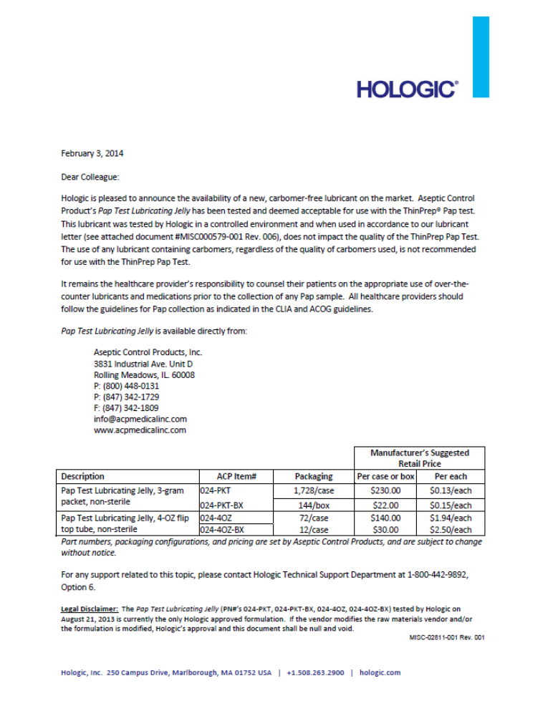
Pathology and Cytology Laboratories
290 Big Run Road
Lexington, KY 40503
(859) 278-9513
1-800-264-0514, Fax: 859-277-6063

TO: Physician Clients
FROM: T.L. Sanderson, M.D., M.S.P.H.
DATE: May, 2002
RE: Pap Smear Technique
Pap smears have decreased cervical cancer 80% over the past 40 years. No other test in medicine has this success rate. The Pap smear is dependent upon frequent and repeated use for this success rate. A single Pap smear may not pick up lesions in over 16 % of cases. If the Pap smear is negative every year for three consecutive years then the false negative rate drops to 0.4%.

Physicians can improve the accuracy of Pap smears with good technique.
  - Biopsy all visible lesions even if Pap smear is negative for the following reasons:
- Pap smears taken on cervical cancer lesions have a 75% false negative rate.
- Normal cells, hyperkeratosis, inflammation and/or blood can be overlying cancer cells that are present.
- Tumor cells grow down below the basement membrane (dysplastic cells grow to the surface epithelium).
    - Repeat Pap smears three to six months after previous abnormal Pap smear - 60% false negative rate if repeated too early (takes time for abnormal cells to reach surface epithelium).
    - Take smears mid cycle (day 12-22); decreases inflammation, obscuring blood; decreases cytolysis; decreases histiocytes and endometrial cells which can be confused with high grade lesions.
    - Do Pap smear prior to bimanual examination.
    - Do not contaminate sample with lubricant.
    - Visualize entire cervix.
    - Gently remove mucus plug from endocervix.
    - Do ectocervical scraping first and then endocervical sample by gently rotating brush only 90 degrees (to reduce bleeding from brush).
    - Rapid fixation. If using spray fixative, hold at least 20 inches away from slide to prevent dispersal and destruction of the cells by the propellant.
    - Small amounts of blood will not interfere with cytologic evaluation, but large amounts preclude cytologic examination.
    - If using Thin Prep technology, be sure to actively disengage mucus and cells from brush/broom into Cytolyte solution.

Patient behavior will affect the adequacy of the specimen.
- 10 % of patients will need their Pap smears repeated due to inflammation or blood which will hide cells (decreased if Pap smear is taken between day 12-22)
- 24 hours before a Pap smear patients should not have intercourse, douche or put anything into the vagina, i.e., cervical caps, vaginal medications, tampons, diaphragms, sponges, etc.
- Reschedule the appointment if menstruating.

D: Blood will interfere with Molecular Testing

METHODS OF COLLECTION FOR
THINPREP PAP TESTS

There are several acceptable methods to obtain a Pap smear, depending upon the preferred method of the clinician.

The conventional pap smear is the method where cervical and endocervical material is spread directly onto a glass slide and then sprayed with a cytology fixative.

The ThinPrep Pap Test is a testing method where the specimen is placed into a vial of liquid fixative and sent to the laboratory. After centrifugation and filtration using an automated system called the ThinPrep Processor, a monolayer slide is prepared. The liquid fixative which dissolves blood and mucus improves the adequacy of the specimen. The fixative cost and additional technical preparation required by the ThinPrep Pap Test makes this method more expensive than the conventional smear.

THINPREP PAP TEST:

The ThinPrep Pap Test is an alternative to the conventional pap smear method. ThinPrep was developed to improve the quality of Pap smear samples. Instead of smearing the sample onto a slide, the physician rinses the cells into a vial filled with PreservCyt cytology fixative. When the laboratory receives the vial, it is placed on an instrument which separates the cells from extraneous matter, such as blood and mucus, which can hide cells. The instrument then places a thin monolayer of cells onto a slide for staining and examination.

Two types of collection devices are available for use with the ThinPrep Pap Test - “the endocervical brush and spatula” and the “broom”. Both types of sampling devices are available from PCL. Be sure to mark the tool you wish to use when ordering the vials of ThinPrep preservative.

NOTE: The same patient information must be provided on the requisition regardless of whether you perform a conventional pap smear or a ThinPrep pap test. Remember, all conventional slides and ThinPrep vials must be labeled with 2 Identifiers.

The following pages provide an illustrated step by step procedure for obtaining a ThinPrep Pap Test using each type of collection tool. A memo from PCL outlining helpful hints for specimen collection is also included.

PCL has available a video you may borrow which shows the correct collection method for ThinPrep Pap Tests. You are encouraged to view this video and talk with our client service department before utilizing this method of screening.

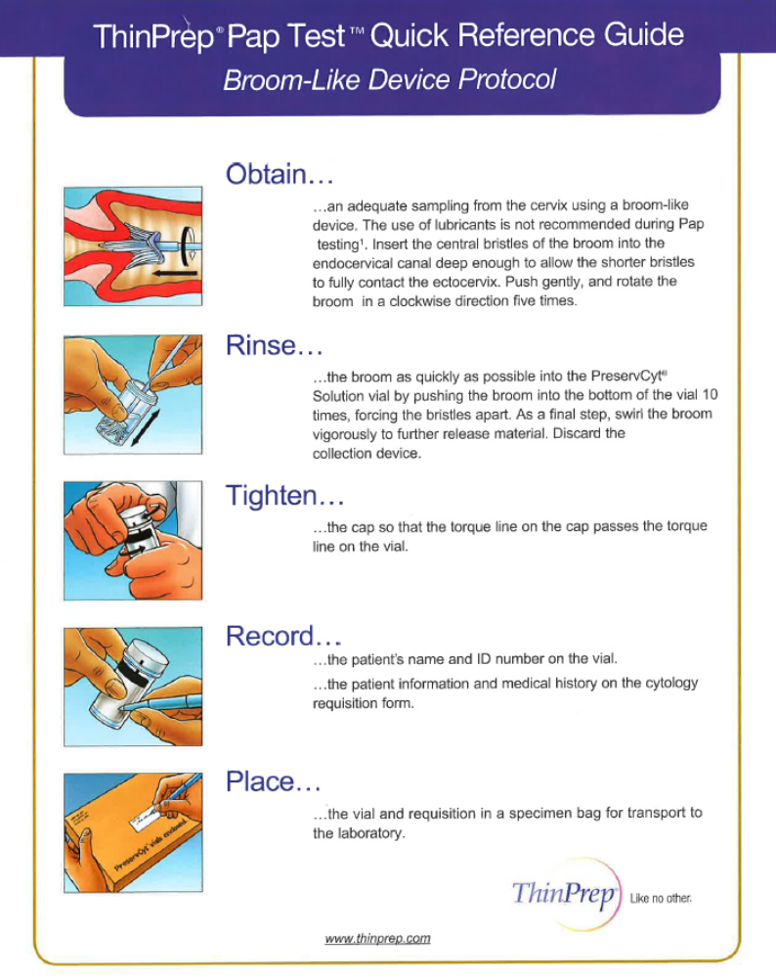
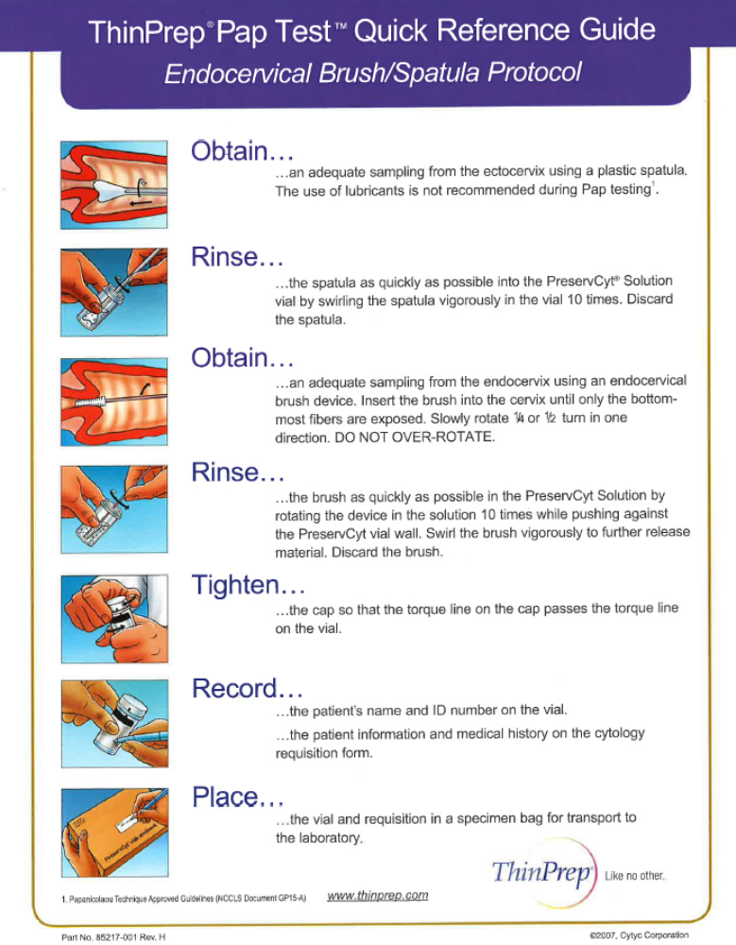
MEMORANDUM

TO: Physician Clients Using Thin Prep Pap Test

FROM: Tamara L. Sanderson, M.D., Director of Cytology

RE: Collection of Thin Prep Pap Test

DATE: May 1, 2002

A gentle swish and discard technique for collection of thin prep specimens is not appropriate for dislodging endocervical components from the brush, spatula or broom apparatus. These cells are often caught in the mucus strands and careful attention must be paid to scraping and rubbing the cells off the collection device. If you have noticed an increase in reports showing lack of endocervical components on your thin prep test, it may be helpful to review the process used in removing the specimen from the collection tool. Remember that removal of the mucus plug before taking a pap smear is essential to obtaining endocervical component, regardless of the collection system used.

If you are using the broom, retrieval of endocervical cells is enhanced when the broom is pushed along the bottom of the vial at least 10 times, allowing the fingers to completely separate. Swirl the broom vigorously throughout the process to further release material.

When using a brush and spatula, a slightly different technique should be used. Following the collection of the specimen, each tool should immediately be vigorously swished in the vial.

HUMAN PAPILLOMAVIRUS and HPV TYPING

It has been proven that genital types of human papillomavirus (HPV) can cause cell changes on the cervix that increase a woman’s risk for cervical cancer.

“Low-risk” types of HPV - HPV types 6 and 11 are the most common types found in genital warts and can be
found in some low-grade SIL or CIN1. Because they are almost never found with cervical cancer, they are considered “low-risk.”

“High-risk” types of HPV - HPV types 16 and 18 are the two most common types that put women at risk for developing cervical cancer. There are 13 or more types of HPV that are associated with cervical cancer. Because of their connection with cervical cancer, these types are called “high-risk.” These types may be found in both low-grade SIL (CIN1) and in high-grade SIL (CIN 2-3).

PCL is performing “High Risk” HPV testing using the Roche cobas HPV Typing Assay. The cobas HPV assay is a qualitative multiplex assay that provides specific genotyping for HPV types 16 and 18 while concurrently detecting the other 12 high risk HPV types in a pooled result (31, 33, 35, 39, 45, 51, 52, 56, 58, 59, 66 and 68)

COMPLETE PROCEDURE FOR COLLECTION OF SPECIMENS FOR HPV TESTING IS LISTED BELOW.

NOTE: HPV typing is a covered service for most insurance carriers if the patient has a previous cytology result of ASCUS, including Medicare and Medicaid.

HPV TESTING

NOTE: Collect Pap smear specimen before application of acetic acid or iodine if a colposcopy will be performed.

HPV reflex testing in conjunction with ThinPrep Pap
- One specimen may be used to provide samples for both the ThinPrep Pap Test and HPV typing.
- The specimen is collected and placed into a ThinPrep (PreservCyt) solution.
- The properly labeled ThinPrep vial (with 2 patient identifiers) is submitted to PCL
- Submit a completed PCL requisition form giving all required pap smear information. To order HPV reflex testing, mark the box “ThinPrep with HPV if Ascus”. To order HPV testing regardless of the diagnosis, check the “ThinPrep with HPV Regardless” box.

HPV Testing without pap smear
- Collect any HPV specimen in a ThinPrep vial (using the same method that you collect a pap test).
- Mark “HPV Only” on the requisition and note on the requisition that a pap test is NOT to be performed.

HPV Testing on Tissue specimens
    - Collect biopsy tissue for HPV by routine colposcopic methods.
    - Place tissue into 10% formalin.
- Label formalin bottle with 2 patient identifiers and site.
- Complete a PCL yellow histology form and note HPV on the requisition at the bottom of the page.

Chlamydia trachomatis & Neisseria gonorrhea Screening

CT/NG nucleic acid is detected utilizing the Roche Cobas 4800. The Roche Cobas CT/NG test uses real-time PCR amplification of target DNA sequences for both CT and NG.

Note: Collect DNA amplification specimen prior to application of acetic acid or iodine if a colposcopy will be performed.

WHEN REQUESTING BOTH PAP CYTOLOGY SCREENING AND CT/GC SCREENING:
- Collect the ThinPrep Pap smear and mark the desired ThinPrep pap test needed and then mark the appropriate CT/GC boxes to order either one or both of the tests.
- Label container and send to PCL as normal.

WHEN REQUESTING CT/GC SCREENING WITHOUT A PAP SMEAR:

- Collect the CT/GC as though a Pap smear was being collected.
- Mark the appropriate CT/GC boxes to order either one or both of the tests. Please note “NO PAP” on the requisition.
- Label the container and send to PCL as normal.

** A OneSwab collection swab may be used for collecting CT/GC testing samples. This method however does not allow a pap smear to be performed.

NOTE – IT IS PREFERRED THAT YOU STILL USE A THINPREP COLLECTION VIAL AND THE SAME TECHNIQUE WHEN COLLECTING A CT/GC. IT MUST BE NOTED ON THE REQUISITION THAT A PAP TEST IS NOT TO BE PERFORMED.

HERPES SIMPLEX VIRUS SCREENING

The COBAS AMPLICOR HSV test is a multiplex polymerase chain reaction (PCR) assay that permits the amplification of Herpes Simplex internal control DNA.

WHEN REQUESTING BOTH PAP CYTOLOGY SCREENING AND HSV SCREENING:

  - Collect ThinPrep Pap smear and mark the desired ThinPrep pap test box to order the pap and then mark the HSV box.
  - Label container and send to PCL as normal.

WHEN REQUESTING HSV SCREENING WITHOUT A PAP SMEAR:

- Collect the HSV as though a Pap smear was being collected.
- Mark the HSV box to order the test. Please note “NO PAP” on the requisition.
- Label the container and send to PCL as normal.

** A OneSwab collection swab may be used for collecting HSV testing samples. This method however does not allow a pap smear to be performed.

NOTE – IT IS PREFERRED THAT YOU STILL USE A THINPREP COLLECTION VIAL AND THE SAME TECHNIQUE WHEN COLLECTING A HSV. IT MUST BE NOTED ON THE REQUISITION THAT A PAP TEST IS NOT TO BE PERFORMED.

VAGINITIS PANEL SCREENING
(Gardnerella Vaginalis, Trichomonas Vaginalis and Candida Albicans)
Vaginitis Panel (Gardnerella, Trichomonas, and Candida Albicans) is performed utilizing the Roche Cobas 4800. The Roche Cobas vaginitis panel (Thin Prep Method and OneSwab, Swab Method) test uses real time PCR amplification.
COMPLETE PROCEDURE FOR COLLECTION OF SPECIMENS FOR VAGINITIS PANEL TESTING LISTED BELOW:
NOTE: Collect Pap smear specimen before application of acetic acid or iodine if a colposcopy will be performed.
VAGINITIS PANEL COLLECTION USING THIN PREP PAP
1: One specimen may be used to provide samples for both the Thin Prep Pap test and vaginitis panel screening.
2: The specimen is collected and placed into a Thin Pap (PreservCyt) solution.
3: The properly labeled Thin Prep vial (with 2 patient identifiers) is submitted to PCL
4: Submit a completed PCL requisition form giving all required Pap smear information. To order vaginitis panel testing, mark the box labeled vaginitis panel at the bottom of the requisition or mark individual tests (Trichomonas, Candida Albicans and/or Gardnerella).
**IT MUST BE NOTED ON THE REQUISITION WHEN A PAP SMEAR SHOULD NOT BE PERFORMED
VAGINTIS PANEL COLLECTION USING UNIPATH SWAB
1: The specimen is collected using a OneSwab (green topped cylindrical tube with swab).
2: The properly labeled OneSwab Swab (2 patient identifiers) is then submitted to PCL.
3: Submit a completed PCL requisition form marking the appropriate tests from the vaginitis panel list at the bottom of the requisition.
NOTE: The One Swab is for the analysis of vaginitis, bacterial, leukorrhea and Candida panels – not for Pap smear testing

VAGINOSIS TESTING FROM THINPREP VIAL OR ONESWAB

Vaginosis testing from the ThinPrep vial is aliquoted and sent to MDL Laboratories. The following tests are performed using PCR assays developed by OneSwab Labs that permits the amplification and detection of the following organisms. The following vaginosis tests can be ran from the pap vial:

Megasphaera 1
C glabrata Megasphaera 2
C tropicalis Mobiluncus curtisii
C parapsilosis Mycoplasma hominis
Mycoplasma genitalium Mobiluncus mulieris
Atopobium vaginae Ureaplasma urealyticum
BVAB2
Bacteroides fragilis
Eggerthella-like bacteria

WHEN REQUESTING BOTH PAP CYTOLOGY SCREENING AND VAGINOSIS TESTING:
- Collect the ThinPrep Pap smear and mark the desired ThinPrep pap test needed
and then mark the appropriate Vaginosis Test(s) box.
- Label container and send to PCL as normal.

WHEN REQUESTING VAGINOSIS TESTING WITHOUT A PAP SMEAR:

- Collect the Vaginosis Test** as though a Pap smear was being collected.
- Mark the appropriate Vaginosis Test(s) box. Please note “NO PAP” on the requisition.
- Label the container and send to PCL as normal.

NOTE – IT IS PREFERRED THAT YOU STILL USE A THINPREP COLLECTION VIAL AND THE SAME TECHNIQUE WHEN COLLECTING FOR VAGINOSIS TESTS. IT MUST BE NOTED ON THE REQUISITION THAT A PAP TEST IS NOT TO BE PERFORMED

** A OneSwab collection swab may be used for collecting vaginosis testing samples. This method however does not allow a pap smear to be performed.
**Please note that a bloody specimen will interfere with Molecular Testing

GROUP B STREP (GBS)

Group B Strep is a PCR based assay developed and performed by MDL Labs. Rectal and Vaginal samples must use separate swabs if GBS testing is desired from both locations.

WHEN TESTING FOR GBS:
- Collect the GBS sample using a GBS by OneSwab which is provided by PCL. Separate swabs are required when sampling Rectal vs. Vaginal areas.
- Label each swab and send to PCL as normal.

NOTE: GBS CANNOT BE RUN OFF THE THINPREP VIAL. IT MUST BE COLLECTED ON THE “GBS ONESWAB” SWAB.

This page is intentionally left blank

NON-GYNECOLOGICAL

SPECIMEN

COLLECTION

NON GYNECOLOGICAL SPECIMENS

INTRODUCTION
Pathology and Cytology Laboratories, Inc. recommends preparing non-gynecologic samples and making slides with the ThinPrep Processor. This procedure requires the specimen to be placed into a vial of CytoLyt cytology fixative and submitted to the laboratory. Following centrifugation and filtration, a monolayer slide is prepared, and stained. This process greatly improves the quality of the smear because lysing of red cells allows increased visibility and centrifugation/filtration increases the volume of diagnostic cells present on the slide. Non-gyn specimens include, but are not limited to: fine needle aspirates, urines, effusions, sputa, respiratory tract, gastrointestinal tract, etc.

PATIENT PREPARATION
Patient preparation varies depending on the type of specimen being collected. Consult each procedure for more specific instructions regarding patient preparation. Sample patient instruction letters are provided for some of the procedures listed in this manual.

CYTOLOGY REQUISITION FORMS - (Addendum D)
A properly completed cytology requisition form should accompany each specimen. All
requisition forms must include:

Required Information
- Patient demographics
- Billing information
- Patient history
- Clinical diagnosis or ICD-10 code
- Source of specimen (i.e., sputum, washings, and brushings)
- Anatomic location (i.e., left, right, upper, lower)
Failure to submit any of the above information will result in a delay in processing the
specimen. Your office will be contacted by telephone or FAX and asked to supply the
necessary information before a report can be issued.

ADDITIONAL CLINICAL INFORMATION
In addition to the information required to process the specimen, additional clinical information should also be documented on the requisition form. Remember that a complete patient history allows PCL to provide you with the highest quality diagnosis for your patient. Examples of additional information are:
- Previous history of abnormal cells
- Current abnormal findings and patient complaints

UNIVERSAL PRECAUTIONS
It must be emphasized that the practice of Universal Precautions should be strictly observed in all phases of collecting, preparing, and transporting specimens for cytology.

FIXATIVE - NON-GYNECOLOGICAL SPECIMENS

Fresh Specimens. CytoLyt Cytology Fixative is the fixative of choice for all fresh specimens such as sputum, body cavity fluids, washings and brushings. The brush used to obtain the specimen should also be placed directly into a container of cytology fixative. We prefer this method because we are able to harvest many more cells from the brush than can be smeared on a slide. The only time it is acceptable to submit an unfixed fluid is when you are ordering an examination of the fluid for crystals. The specimen container must be clearly marked as “unfixed specimen for crystals”.

NOTE: CytoLyt Fixation does not require equal amounts of specimen and fixative to be mixed.

When adding fresh specimens to CytoLyt, do not discard any of the fixative. For volumes less than 20 mls, add the entire specimen to a vial of CytoLyt. In some circumstances (i.e., fluids from paracentesis, thoracentesis, etc.) the amount of specimen may be large. Do not send the entire specimen. A well-mixed representative aliquot of up to 20 ml of specimen added to the entire contents of a container of cytology fixative is adequate. Record the total original volume of the specimen in the appropriate place on the Cytology Request Form.

Pre-made Smears - Wet fixation. If the physician chooses to make smears, they may be placed into a vial of CytoLyt along with any collection brush being submitted or they may be put into a separate vial of CytoLyt. Please put slides into the container back-to-back or put a plastic paper clip on one slide to prevent them from sticking together. Please DO NOT use metal paper clips, they will rust. If no CytoLyt is available, use 95% ethyl alcohol for wet fixation.

Pre-made Smears - Spray fixation. If the physician chooses to make smears and does not have the CytoLyt fixative, the smears may be sprayed with the cytology fixative used for pap smears.

Pre-made Smears - Air Dried. Occasionally a physician will elect to submit an air dried smear on fine needle aspirates. These smears should be marked as “air dried” so they can be differentiated from pre-made smears that are spray fixed.

*** If no CytoLyt or cytology spray fixative is available, see the emergency substitution list below for alternate choices for specimen fixation. Whenever a substitution is made, the type of fixative used must be noted on the laboratory requisition to ensure proper processing of the sample.

EMERGENCY SUBSTITUTIONS FOR CYTOLOGY FIXATIVE
Fresh Non-gynecological specimens may be placed in one of the fixatives below if no CytoLyt cytology fixative is available. The vial containing the specimen must be clearly labeled with the type of substitute fixative used.
- Ethyl Alcohol - add equal parts of 100% ethyl alcohol and tap water to give a 50% dilution. Mix equal amounts of diluted fixative and specimen.
- Cytology spray fixative - this fixative is 95% ethanol. To obtain an approximate 50% dilution, add 5 parts spray fixative to 4 parts tap water. Mix equal amounts of diluted fixative and specimen.
- Rubbing Alcohol - this is 70% isopropyl alcohol. To obtain an approximate 50% dilution, add 5 parts alcohol to 2 parts tap water. Mix equal amounts of diluted fixative and specimen.

SPECIMEN LABELING
All non-gynecological cytology specimen containers must be labeled with the patient’s
first and last name along with a 2nd form of identification and source of specimen. You may attach a preprinted addressograph label to the specimen container or write the patient name directly on the vial with a permanent magic marker.

If there are multiple specimens on the same patient, you must mark each container with
the source of specimen as well as the patient name and 2nd identifier. We cannot render separate diagnosis unless each specimen is clearly labeled as to its source.

PREPARATION FOR TRANSPORT
Specimens submitted in liquid fixative always have the potential for leaking. When leakage occurs, it results in a potentially hazardous condition for couriers and other persons handling the specimen during transport and processing. It also limits the amount of specimen available for testing, thus decreasing the quality of the results.

Before submitting a CytoLyt vial to PCL, make sure the lid is securely tightened. Place the vial into a plastic, Ziploc PCL transport bag. DO NOT place the laboratory requisition inside the Ziploc bag. Place the requisition and other papers in the pouch on the outside of the transport bag. If no pouch is present, put the requisition inside a second Ziploc bag and then place it inside the original transport bag with the specimen.

Plastic collection cups and urine containers are often not designed for courier transportation of liquid specimens. These containers are much more likely than our CytoLyt vials to spill or leak. Before sending a specimen in a container other than the CytoLyt vial, check to see that the lid is securely fastened. Additional protection can be obtained by wrapping parafilm over the lid and around the sides of the container.

NOTE: Specimens are never to be submitted to Pathology & Cytology Laboratories, Inc. in a syringe or other hazardous collection device.
BRONCHIAL WASHINGS

- The bronchial washing is collected into the lavage container. 1 aliquot of 20 cc
should be added to a pre-filled tube of cytology fixative as soon as possible. If no cytology fixative is available, 50% ethyl alcohol may be used.
- The specimen containers must be labeled with 2 patient identifiers, source of specimen and date of collection.
- Universal Precautions should be strictly observed in all phases of collecting, preparing, and transporting specimens for cytology.
- Send the specimen to the laboratory with a completed Cytology Requisition Form. (Addendum A)

NOTE: All requisition forms must include the following:
- Patient demographics
- Billing information
- Patient history
- Clinical diagnosis or ICD-10 code
- Source of specimen (i.e., sputum, washings, and brushings)
- Anatomic location (i.e., left, right, upper, lower)

*Bronchial washings from different lobes will be considered as different specimens and therefore require separate requisition forms, properly identified.

- Please tighten the caps of the cytology fixative tube securely to prevent leakage during transportation. Place the labeled specimen container into the Ziploc portion of the transport bag and seal tightly. Place the completed requisition into the flapped pouch on the outside of the transport bag.

REFERENCES:
1. Koss, Leopold G., Diagnostic Cytology and Its Histopathologic Bases. Third Edition, 1979.
2. Holmquist, Marion D., CT(ASCP), CFIAC, and Keebler, Catherine M., CT(ASCP), ScD (hon), "Cytopreparatory Techniques", A Manual of Cytotechnology, 6th Ed., pp. 331-332.

BRONCHIAL BRUSHINGS

- It is preferable to submit the bronch brush in cytology fixative rather than sending pre-made slides.

- In the event that you have no cytology fixative, the brush may be placed immediately after collection in a container of 50% ethyl alcohol. The requisition should state that the brush is in alcohol because alcohol fixed specimens are processed by a different method than specimens fixed in cytology fixative.

- An alternative method, but not the preferable one, is to prepare the slides at the time of collection. This can be accomplished by the following procedure:

              - Label slides in lead pencil with the patient's name and source of specimen (right upper lobe as RUL, etc).
              - Transfer material by rolling the brush from left to right over the entire smooth surface of the slide. Two to four slides may be made.
              - Immediate fixation is essential. Place the slide(s) into a container of cytology fixative or 95% ethyl alcohol if no cytology fixative is available. To prevent the slides from sticking together, plastic, not metal, paper clips should be placed on the end of each slide. Metal paper clips will rust quickly in the fixative and leave a brown residue on the slide.

- The specimen container must be labeled with 2 patient identifiers, source of specimen and date collected.

- Universal Precautions should be strictly observed in all phases of collecting, preparing, and transporting specimens for cytology.

- Send the specimen to the laboratory with a completed Cytology Requisition Form. (Addendum A)

NOTE: All requisition forms must include the following:
- Patient demographics
- Billing information
- Patient history
- Clinical diagnosis or ICD-10 code
- Source of specimen (i.e., sputum, washings, and brushings)
- Anatomic location (i.e., left, right, upper, lower)

7. Please tighten the caps of the cytology tube securely to prevent leakage during transportation. Place the labeled specimen container into the Ziploc portion of the transport bag and seal tightly. Place the completed requisition into the flapped pouch on the outside of the transport bag.
REFERENCES:
1. Koss, Leopold G., Diagnostic Cytology and Its Histopathologic Bases. Third Edition, 1979.
2. Holmquist, Marion D., CT(ASCP), CFIAC, and Keebler, Catherine M., CT(ASCP), ScD (hon), "Cytopreparatory Techniques", A Manual of Cytotechnology, 6th Ed., pp. 331-332.
SPUTUM

One sputum specimen each morning for three successive days should be collected to ensure a maximum of diagnostic accuracy. Often, patients with diagnostic lung problems are cigarette smokers, and after the discussion on the type of sputum sample desired, they know exactly what is needed. They will readily admit that on arising from bed they cough up material from deep in the lungs. Ninety percent of all patients will yield a satisfactory specimen spontaneously on arising from a nights sleep. The remaining 10% of the patients who do not cough must be administered an aerosol.

ROUTINE SPUTUM
A "deep" cough specimen is required for bringing up material from the small bronchi and the alveoli.

AEROSOL SPUTUM
The cough reflex may be stimulated artificially by means of inhalation of cough-stimulating substances. Non-coughing patients must be administered an aerosol with the use of a nebulizer. Nebulization will usually produce a productive cough within the next 24 hours. The patients should be given a bottle containing fixative and instructions for collecting a sputum sample during this period of time.

POST-BRONCHIAL SPUTUM
The diagnostic yield of cytologic samples and recovery of materials beyond the reach of the flexible scope makes this a valuable diagnostic procedure.

GENERAL INSTRUCTIONS

    - Have patient rinse mouth thoroughly with water.

  - Obtain sputum specimen using one of the above methods.

  - Add the sputum specimen to a pre-filled bottle of cytology fixative or pour the entire tube of fixative over the specimen in the sputum cup. Immediate fixation is essential. If no cytology fixative is available, 50% ethyl alcohol may be used. Please note on the requisition that alcohol has been substituted because alcohol fixed specimens are processed by a different method than specimens fixed in cytology fixative.

4. The specimen container must be labeled with the patient's name, source of specimen and date of collection.

5. Universal Precautions should be strictly observed in all phases of collecting, preparing, and transporting specimens for cytology.
6. Send the specimen to the laboratory with a completed Cytology Requisition Form.

NOTE: All requisition forms must include the following:
- Patient demographics
- Billing information
- Patient history
- Clinical diagnosis or ICD-10 code
- Source of specimen (i.e., sputum, washings, and brushings)
- Anatomic location (i.e., left, right, upper, lower)
**Please indicate on the form which type of sputum is submitted.

7. Please tighten the caps of the cytology fixative tube securely to prevent leakage during transportation. Place the labeled specimen container into the Ziploc portion of the transport bag and seal tightly. Place the completed requisition into the flapped pouch on the outside of the transport bag.

REFERENCES:
1. Koss, Leopold G., Diagnostic Cytology and Its Histopathologic Bases. Third Edition, 1979.
2. Holmquist, Marion D., CT(ASCP), CFIAC, and Keebler, Catherine M., CT(ASCP), ScD (hon), "Cytopreparatory Techniques", A Manual of Cytotechnology, 6th Ed., pp. 331-332.

NOTE: If the sputum specimens are to be collected on an outpatient basis, you must provide the patient with the following:
1. Three (3) sputum collection cups and three (3) vials of cytology fixative. The cups should be labeled with the patient's name and date of collection.
2. An instruction sheet for the patient to use during collection. An example form has
been provided.

PATHOLOGY & CYTOLOGY LABORATORIES, INC.
290 BIG RUN ROAD
LEXINGTON, KY 40503
(859)278-9513 Toll Free (800)264-0514

Dear ________________________________

Dr. _________________________________ has requested that you collect sputum
specimens for cytologic examination in our laboratory. The type of specimen required
is a deep cough specimen, not just saliva. Often people with diagnostic lung problems
are familiar with the material that can be coughed up from deep in the lungs immediately after arising from bed. Ninety percent of all patients will yield a satisfactory specimen spontaneously on arising from a nights sleep. The remaining 10% of the patients who do not cough must be administered an aerosol.

Here are a few simple but important instructions for you to follow:

1. On arising in the morning, rinse your mouth thoroughly with water.

2. Breath deeply several times and cough deeply until you feel you have a specimen from deep in your lungs. Put this specimen into the cup which has been provided for you. After collection, pour the entire tube of provided fixative over the sputum. Seal lid tightly and shake the container gently for a few seconds.

3. Deliver the specimen to your physician or laboratory.

PRECAUTIONARY MEASURES:
Fixative may be fatal if swallowed and harmful if inhaled.
Fixative is flammable.
Keep container closed and use with adequate ventilation.
Wash thoroughly after handling.

BODY CAVITY FLUIDS

Pleural, peritoneal, pericardial, and pelvic washes

    - Fluids must have fixative added as shortly as possible after collection. The size of the sample should not exceed 40 ml. Fluids in excess of this amount should be mixed well to insure the cellular elements are evenly dispersed. Two aliquots of 20 ml each of the unfixed fluid should be poured off and added to two prefilled tubes of Cytolyte cytology fixative provided by PCL. Use 50% ethyl alcohol if no cytology fixative is available but mark on the tubes that alcohol was used. These specimens will need to be processed differently.

  - The specimen containers must be labeled with 2 patient identifiers, source of specimen
and date of collection.

3. Universal Precautions should be strictly observed in all phases of collecting, preparing, and transporting.

4. Send the specimens to the laboratory with a completed Cytology Requisition Form.

NOTE: All requisition forms must include the following:
- Patient demographics
- Billing information
- Patient history
- Clinical diagnosis or ICD-10 code
- Source of specimen (i.e., sputum, pleural fluid, urine, and breast)
- Anatomic location (i.e., left, right, upper, lower)

5. Please tighten the caps of the cytology fixative tubes securely to prevent leakage during transportation. Place the labeled specimen container into the Ziploc portion of the transport bag and seal tightly. Place the completed requisition into the flapped pouch on the outside of the transport bag.

BODY CAVITY FLUIDS FOR CRYSTALS

Crystal analysis on body cavity fluids can be submitted to Pathology & Cytology Laboratories. PCL DOES NOT perform any chemical testing, cell counts or cultures on fluids. For these procedures, send the fluid to your clinical laboratory. For joint fluid crystals, biliary crystals and cholesterol crystals, use the protocol described below.

PROCEDURE:

    - Collect the fluid and place in a clean container. DO NOT ADD FIXATIVE.

  - Label the container with 2 patient identifiers, source of specimen, and mark on the container that the specimen is UNFIXED.

3. Complete a PCL cytology requisition form. Mark in the Non-Genital Cytology Sections (found in the lower third of the form) the type of fluid being submitted and state it is an unfixed fluid for crystals only.

4. Place container and requisition in a PCL transport bag and send to PCL.

*PCL will make slides from the fluid submitted. It is not necessary for you to make and submit any slides.

REFERENCE:
Demay, Richard M., The Art & Science of Cytopathology, Vol. 1., Exfoliative Cytology. P. 259, 1996.
Walshe ADP, Douglas JG, Kerr KM, et al: An Audit of the Clinical Investigation of Pleural Effusions. Thorax 47: 734-737, 1992.
Salyer, WR, Eggleston JC, Wrozan YS: Efficacy of Pleural Needle Biopsy and Pleural Fluid Cytopathology in the Diagnosis of Malignant Neoplasm Involving the Pleura. Chest 67: 536-539, 1975.
Venrick MG, Sidaway MK: Cytologic Evaluation of Serous Effusions: Processing Techniques and Optimal Number of Smears for Routine Preparation. Am J Clin Pathol 99: 182-186, 1993.

URINARY TRACT

URINE
Three separate samples of urine obtained on consecutive days are recommended. The first morning specimen should not be collected for cytologic evaluation. The first morning urine should be discarded and the next urine specimen should be submitted.

The following procedure should be used to collect urine for cytology samples:

1. Discard the first morning voided specimen.

2. Drink one glass of water every 15 minutes for 2 hours.

3. Collect urine from the next voided specimen and add up to 20 ml of urine to the pre-filled containers of cytology fixative provided by PCL. Use 50% ethyl alcohol if no cytology fixative is available. If more than 20 ml of urine is collected, mix it well to insure the cellular elements are evenly dispersed and then aliquot up to 20 ml and pour into pre-filled containers.

BLADDER WASHINGS
Washings of the bladder with Ringer's solution may be collected at the time of cystoscopy. (Do not use saline because it will decrease the specimen quality by lysing many of the cells.)

RENAL PELVIS AND URETERS
Special procedures, such as retrograde catheterization or direct brushings, may assist in the localization of lesions of the upper urinary tract. Renal brushes should be fixed immediately by placing them in a container of cytology fixative.

PROSTATE SECRETIONS
A secretion obtained by prostatic massage is collected directly on a slide. The fluid is spread with another slide and fixed immediately by cytology spray fixative or by dropping the slide into cytology fixative or 95% ethyl alcohol. The slide must be labeled in lead pencil with the patient's name.

COLLECTION OF URINE AFTER PROSTATE MASSAGE
A voided specimen is collected before and again after massage. Label each specimen, indicating whether it was obtained before or after massage.

GENERAL INSTRUCTIONS

1. All urines and washings are to be fixed as soon as possible after collection. Place, from several drops up to 20 ml of urine, into the pre-filled containers of cytology fixative provided by PCL.

2. The specimen container must be labeled with 2 patient identifiers, source of specimen and date of collection.

3. Universal Precautions should be strictly observed in all phases of collecting, preparing, and transporting specimens for cytology.

4. Send the specimen to the laboratory with a completed Cytology Requisition Form.

NOTE: All requisition forms must include the following:
- Patient demographics
- Billing information
- Patient history
- Clinical diagnosis or ICD-10 code
- Source of specimen (i.e., sputum, pleural fluid, urine, and breast)
- Anatomic location (i.e., left, right, upper, lower)

5. Please tighten the caps of the cytology fixative tube securely to prevent leakage during transportation. Place the labeled specimen container into the zip-lock portion of the transport bag and seal tightly. Place the completed requisition into the flapped pouch on the outside of the transport bag.

REFERENCES:
1. Koss, Leopold G., Diagnostic Cytology and Its Histopathologic Bases. Third Edition, 1979.
2. Holmquist, Marion D., CT(ASCP), CFIAC, and Keebler, Catherine M., CT(ASCP), ScD (hon), "Cytopreparatory Techniques", A Manual of Cytotechnology, 6th Ed., pp. 331-332.

PATHOLOGY & CYTOLOGY LABORATORIES, INC.
290 BIG RUN ROAD
LEXINGTON, KY 40503
(859)278-9513 Toll Free (800)264-0514

Dear______________________________

Dr. _______________________________ has requested that you collect urine
samples for cytologic examination in our laboratory. The first morning specimen
should not be collected for cytologic examination. The first morning urine should
be discarded and the next urine specimen should be submitted.

Here are a few simple but important instructions for you to follow:

Discard the first morning voided urine specimen.

Drink one glass of water every 15 minutes for 2 hours.

Collect urine from the next voided specimen. Immediately pour 20 ml of
urine into the prefilled container of cytology fixative provided by PCL.
Seal the lid tightly and shake the container gently for a few seconds.
If tests other than a cytologic evaluation have been ordered, the remainder
of the urine may be acceptable for this testing. Consult your physician or
laboratory for instructions.

Deliver the specimen to your physician or laboratory.

PRECAUTIONARY MEASURES:
Fixative may be fatal if swallowed and harmful if inhaled.
Fixative is flammable.
Keep container closed and use with adequate ventilation
Wash thoroughly after handling.

GASTROINTESTINAL TRACT

Brushings and washings of the esophagus, stomach, duodenum, and colon must be performed PRIOR to any tissue biopsy being performed at the same time.

BRUSHINGS
It is preferable that the brush be fixed immediately in cytology fixative provided in pre-filled containers by PCL. If no cytology fixative is available, 50% ethyl alcohol may be used. If the physician wishes to submit pre-made smears in addition to the brush, the slides should be fixed immediately by spray fixative or dropped into a container of cytology fixative. If no cytology fixative is available, 95% ethyl alcohol may be used. Plastic paper clips placed on the end of the slides will keep the slides from sticking together. Please do not use metal paper clips as they rust quickly in the fixative and leave a brown residue on the slides.

If slides are going to be submitted, the brush must be carefully, yet rapidly, withdrawn from the instrument and the smears prepared without any delay. The brush should be gently rotated on a limited area of the surface of the slide. The cytologic material should not be crushed. To prevent drying, the slide must be immediately placed in the fixative.

WASHINGS/LAVAGE
Immediately after aspiration of the fluid, up to 20 cc of fluid should be placed in a pre-filled tube of cytology fixative.

GENERAL INSTRUCTIONS

1. The specimen container must be labeled with 2 patient identifiers, source of specimen and date of collection.

2. Universal Precautions should be strictly observed in all phases of collecting, preparing, and transporting specimens for cytology.

3. Send the specimen to the laboratory with a completed Cytology Requisition Form.

NOTE: All requisition forms must include the following:
- Patient demographics
- Billing information
- Patient history
- Clinical diagnosis or ICD-10 code
- Source of specimen (i.e., esophagus, stomach, duodenum, and colon)
- Anatomic location (i.e., upper, lower, left, right)

4. Please tighten the caps of the cytology fixative tube securely to prevent leakage during transportation. Place the labeled specimen container into the Ziploc portion of the transport bag and seal tightly. Place the completed requisition into the flapped pouch on the outside of the transport bag.

REFERENCES:
1. Koss, Leopold G., Diagnostic Cytology and Its Histopathologic Bases. Third Edition, 1979.
2. Holmquist, Marion D., CT(ASCP), CFIAC, and Keebler, Catherine M., CT(ASCP), ScD (hon), "Cytopreparatory Techniques", A Manual of Cytotechnology, 6th Ed., pp. 331-332.

CEREBROSPINAL FLUIDS

1. Spinal fluids are to be fixed as soon as possible after collection. Place several drops up to 20 ml of spinal fluid into the pre-filled container of cytology fixative provided by PCL. Use 50% ethyl alcohol if no cytology fixative is available.

2. The specimen container must be labeled with 2 patient identifiers, source of specimen and date of collection.

3. Universal Precautions should be strictly observed in all phases of collecting, preparing, and transporting specimens for cytology.

4. Send the specimen to the laboratory with a completed Cytology Requisition Form.

NOTE: All requisition forms must include the following:
- Patient demographics
- Billing information
- Patient history
- Clinical diagnosis or ICD-10 code
- Source of specimen (i.e., esophagus, stomach, duodenum, and colon)
- Anatomic location (i.e., upper, lower, left, right)

5. Please tighten the caps of the cytology fixative tube securely to prevent leakage during transportation. Place the labeled specimen container into the Ziploc portion of the transport bag and seal tightly. Place the completed requisition into the flapped pouch on the outside of the transport bag.

REFERENCES:
1. Koss, Leopold G., Diagnostic Cytology and Its Histopathologic Bases. Third Edition, 1979.
2. Holmquist, Marion D., CT(ASCP), CFIAC, and Keebler, Catherine M., CT(ASCP), ScD (hon), "Cytopreparatory Techniques", A Manual of Cytotechnology, 6th Ed., pp. 331-332.

NIPPLE SECRETIONS AND
BREAST FINE NEEDLE ASPIRATIONS

BREAST FINE NEEDLE ASPIRATIONS
The aspiration should be immediately expelled from the syringe into a container of cytology fixative provided by PCL. The syringe may be rinsed by drawing up some fixative and expelling it back into the fixative container. Use 50% ethyl alcohol if cytology fixative is not available. It is preferable that PCL make the slides, but if the physician wants to make slides in addition to sending us the specimen, the slides should be spray fixed immediately or placed into a container of cytology fixative or 95% ethyl alcohol if there is no cytology fixative available.

NIPPLE SECRETION SMEARS
Spray the smear immediately with cytology spray fixative. Allow to dry before placing in the specimen container. Labeling of the slide with the patient's name in lead pencil is required.

GENERAL INSTRUCTIONS

1. The transport container must be labeled with 2 patient identifiers, source of specimen and date of collection.

2. Universal Precautions should be strictly observed in all phases of collecting, preparing, and transporting specimens for cytology.

3. Send the specimen to the laboratory with a completed Cytology Requisition Form.

NOTE: All requisition forms must include the following:
- Patient demographics
- Billing information
- Patient history
- Clinical diagnosis or ICD-10 code
- Source of specimen (i.e., sputum, pleural fluid, urine, and breast)
- Anatomic location (i.e., left, right, upper, lower)

4. Please tighten the caps of the cytology fixative tube securely to prevent leakage during transportation. Place the labeled specimen container into the Ziploc portion of the transport bag and seal tightly. Place the completed requisition into the flapped pouch on the outside of the transport bag.
REFERENCES:
1. Koss, Leopold G., Diagnostic Cytology and Its Histopathologic Bases. Third Edition, 1979.
2. Holmquist, Marion D., CT(ASCP), CFIAC, and Keebler, Catherine M., CT(ASCP), ScD (hon), "Cytopreparatory Techniques", A Manual of Cytotechnology, 6th Ed., pp. 331-332.

QUICK REFERENCE GUIDE

FINE NEEDLE ASPIRATION PREPARATION TECHNIQUES
(Complete FNA collection procedure outlined on following pages)
Thyroid and Salivary Gland Lesions
    - On the first pass, one or two drops of aspirate are placed on glass slides and direct smears are prepared by placing the slides together, allowing the material to spread evenly and then twisting or gently pulling the two slides apart. Spray fix one slide with alcohol fixative and allow the other to air dry. The air-dried smear will be stained by Wright or Giemsa stain. Please label each slide with patient name and mark as “fixed” or “air-dried”. It can be difficult to tell the fixation method once the slides are dry.
    - If more than two drops of material are obtained on the aspirate pass, the remaining fluid should be placed in CytoLyt cytology fixative (green top conical shaped tube) by rinsing the needle and syringe into the CytoLyt tube.
    - Generally, the lesion will be aspirated in three to six attempts. Each attempt may be handled similar to the above or after the first attempt, the material may be placed directly in the CytoLyt fixative.

Aspirates of Suspected Lymphoma
- On the first pass, one or two drops of aspirate are placed on glass slides and direct smears are prepared by placing the slides together, allowing the material to spread evenly and then twisting or gently pulling the two slides apart. One smear should be immediately sprayed with alcohol fixative used for Pap smear fixation and the other smear allowed to air dry for Wright or Giemsa staining. In addition to labeling the slides with the patient name, the slides should be marked as “air-dried” or “fixed”. It can be difficult to tell the fixation method once the slides are dry.

- Any additional material from the first pass plus material from at least two subsequent passes should be rinsed directly into RPMI lymph node transport media (pink solution supplied by PCL) and refrigerated. After rinsing, the liquid should be definitely cloudy to the eye. If a cloudy appearance is not observed, it is unlikely there will be enough material in the vial for testing.

- Additional passes can be performed and material rinsed directly into CytoLyt. If desired, the first one or two drops can be used to prepare direct smears using the technique described above with the remaining material from each pass placed in the CytoLyt vial.

* These suggestions are meant as a general approach; they are not standards. Each case may present special clinical and diagnostic needs that require alternative methods of collection. Clinicians may have different techniques and preferences that work as well in their practice. However, it is important to note that at least 30% of lymph node aspirates will require immunophenotyping from RPMI media to exclude or diagnosis non-Hodgkin’s lymphoma.

Fine Needle Aspiration (FNA) Technical Considerations

Successful FNA is dependent upon extensive skill in biopsy aspiration, specimen preparation, laboratory processing, staining and microscopic evaluation.

Technical Considerations:
  - Sample size
- Multiple samples from different areas of the mass are necessary (3 to 6 passes into mass). Thyroid, Lymph Node and bloody lesions may require additional sampling.

  - Needle size
- 1.5 inch 25 gauge is successful for most palpable masses
- 1.5 inch 23 gauge is necessary for breast, fatty lesions or dense fibrous lesions

  - Syringe size
- Affects degree of negative pressure and needle placement/control
- 10 ml syringe is optimal
- Fibrous and fibro fatty tissues - 2 to 5 ml of vacuum is helpful
- Thyroid, lymph nodes and other vascular lesions - no vacuum prevents undesirable blood dilution (use capillary action of needle to collect cellular sample)

- Aspiration technique

  - Lay out and label slides prior to aspiration
  - Anesthetize a tract between skin and edge of mass (do not inject lesion itself)
  - Draw 0.5 to 1.0 ml air into syringe (to allow specimen expression after sampling)
  - The free hand is used to stabilize and define the margins of the target
  - Once the sampling needle is at the edge of the lesion, 2 to 5 mm. of negative pressure is applied as the needle is moved first into the lesion, then moved back and forth within the lesion in short (5mm), reciprocating, vibration-like motions with minimal to no redirection.
    - If blood fills the needle hub, discontinue negative pressure
    - If blood does not fill the hub, then the aspiration is discontinued after 20 to 25 reciprocation strokes
    - To avoid accidental aspiration into the syringe, negative pressure must be released before removing the needle
  - Up to six samplings may be required for adequate cellular material. Different regions of larger lesions should be systematically sampled. “Non-aspiration” sampling technique is very helpful for thyroid, lymph nodes, bloody lesions or very small, firm targets.
- Using 1.5 inch 25-guage needle with 3 ml syringe with piston removed allows a “dart-like” grip at the syringe/needle hub interface
- Using 5 mm vibrating motions (20-25 times) capillary action will produce an excellent concentrate of 1 to 2 drops of specimen

- Smear and cell suspension preparations

  - Specimen volume per smear preparation is best kept to 3 drops or less
  - The needle tip is placed down on the center of a plain glass slide.
  - The specimen is expressed in the center of a plain glass slide using the air initially in the syringe.
  - A second plain slide is next placed “face-to-face” with the first to spread the specimen pooling into a thin monolayer.
- It is best to allow the specimen pool to spread between the slides naturally before pulling the slides apart along the short axis.
- One slide is air-dried and the other is immediately(less than 2 seconds) placed into 95% alcohol, Cytolyte (wet-fixed) or fixed with cytology spray fixative.
- “Tapping out specimen” - Any specimen left in the needle hub can often be tapped out. To do this, the needle shield is carefully replaced and the needle is grasped tightly like a pencil with the hub down. A slide is placed on a flat, firm, unpadded surface and the hub is sharply “tapped” to expel the material on the center of a slide (multiple sharp taps may be required).
- After the slides are made, needles and hubs should be rinsed into Cytolyt.
- If specimen is bloody, air dry slides or place in Cytolyt (do not wet-fix in alcohol). Remember to rinse all needles in Cytolyt. Bloody specimens can be allowed to sit on a slide 3 to 4 seconds. The slide is gently tilted to allow blood to run to one edge, without spilling over. Excess blood is re-aspirated into the needle. If tissue is present, small visible particles are seen on the slide, this can be smeared as above. This slide can now be made into paired smears. If large tissue fragments are expelled onto slides from FNA, use a wooden stick to transfer to Cytolyte and lab will prepare a cell block.

________________________________________________________
Reference from M.Glant, Diagnostic Cytology Laboratories.

FINE NEEDLE ASPIRATION

- Label and number slides

- Aspiration Technique
- Start with 1 ml air in syringe
- Use 2-4 ml of suction
- Use short in and out reciprocating strokes (5-8 mm), staying in the mass
- Stop all suction before specimen fills the needle hub, or after 20-25 strokes
- Release suction by allowing the plunger to return to the 1 ml mark
- Remove the needle quickly
- Immediately prepare the smears from each sample
- Immediately prepare the smears from each sample before additional collections
- Non-Aspiration Technique
- Remove syringe plunger from 3 ml syringe
- Insert needle into the edge of lesion
- Use short in and out reciprocating strokes (5-8 mm), staying in the mass
- Stop as specimen fills the needle hub, or after 20-25 strokes
- Remove needle quickly
- Place needle over slide BEFORE reinserting the syringe plunger to express the sample
- Immediately prepare the smears from each sample before additional collections

- Direct Smear Preparations

NOTE: Slides are numbered as pairs 1-2 and should be used as pairs (1 with 1, 2 with 2, etc…)
- Point needle down and slowly express specimen onto the center of the slide
- An optimal “smear volume” is 2-3 drops (about 1 cm specimen pool or “dime sized”)
- If the specimen is bloody and more than 5 drops, tilt the slide so the excess pools at one edge. Reaspirate excess back into the needle (place in rinse tube later). Immediately prepare smears with reduced volume specimen
- The slides are placed “face-to-face” and the specimen pool spreads by the natural cohesion. DO NOT PRESS THE SLIDES TOGETHER FIRMLY.
- Smear “sideways” by holding the lower slide still while moving the upper slide away from you KEEPING THE SLIDES PARALLEL. Do this near the open container of liquid fixative.
- IT IS CRITICAL TO IMMEDIATELY IMMERSE ONE SLIDE in a large container of alcohol-based fixative or spray the slide with cytology fixative
- The other slide must be laid flat with the smear up and allowed to air dry
- Two wet-fixed slides can be placed back-to-back in alcohol-based fixative or Cytolyte Solution

The key elements for success are…

Limit the volume to be smeared (2-3 drops) and place it in the center of the slide. If your samples are routinely over 6 drops then you need to stop aspiration sooner or use the non-aspiration technique.

Pick up the slide with the specimen and place the other slide “face-to-face” with the first and allow the specimen pool to spread. At first it spreads quickly and then slows nearly to a stop. The best time to begin smearing the slides is just as it slows spreading. The slides will hold together by the natural cohesion created by the specimen pool. Do not press the slides firmly together, this may crush the fragile microscopy.

Smearing is done by keeping the lower slide still as the upper slide is moved sideways, keeping the slides parallel. It is best to hold the slides between the thumb and index finger. Minimal pressure is used to hold the slides together. The specimen’s natural cohesive nature is usually sufficient to keep the slides together (until the smearing motion separates the slides beyond about half their width). Try to keep the slides parallel until they separate…creating two nearly identical arched-shaped cell spreads.

- Tapping Out Specimen
At times, a small amount or the entire specimen remains in the needle hub. If this occurs, the specimen can be “tapped” out by the following technique.
  - The needle shield is carefully replaced and is grasped tightly like a pencil with the hub down
  - A slide is placed on a flat, firm, unpadded surface and the hub is sharply “tapped” to expel the material on the center of a slide. Multiple sharp taps may be required.

- Rinse Solution
At the completion of the biopsy, the needles can be rinsed with Cytolyte solution. Often three to four “extra” aspirations are directly expressed into the Cytolyte solution to allow for cell block, ThinPrep, etc…

BUCCAL SMEARS FOR SEX CHROMATIN POSITIVE BODIES
(BARR BODIES)

- Wipe the mucous membrane of the inner cheek gently with gauze to remove surface bacteria and debris.
- Scrape this area with a wooden tongue blade or Pap scraper until a visible amount of whitish material is seen on the blade.
- Transfer to a glass slide labeled with the patient’s name. Spread thinly and fix immediately by spraying with cytology fixative spray. At least four (4) slides are required.
- Send the specimen to the laboratory with a completed Cytology Request Form.

NOTE: All request forms must include the following:
- Patient demographics
- Billing information
- Patient history
- Clinical diagnosis or ICD-10 code
- Source of specimen (i.e., sputum, pleural fluid, urine, and breast)

REFERENCE:
Keebler, Catherine and Reagan, James, A Manual of Cytotechnology. 6th Ed., 1983.

MISCELLANEOUS

CYSTS
Renal, ovarian, pancreas, liver, bone, subcutaneous, etc are collected and fixed for transport as body cavity fluids.

PELVIC WASHINGS
Pelvic washings are collected and transported as body cavity fluids.

PENILE DISCHARGE
Penile discharge and prostatic secretions are collected and fixed for transport just as a nipple secretion smear is collected.

DRAINAGE SPECIMENS
Drainage specimens are collected and fixed as nipple secretion smears if the specimen is small or as body cavity fluids if the specimen is more than enough for several smears.

ULCER SMEARS
Ulcer smears are collected and fixed as nipple secretion smears.

CELL BLOCKS
Cell blocks will be performed on specimens if there is enough sediment with the exception of sputum which is very mucoid and spinal fluid which is usually hypocellular.

JOINT FLUIDS
Joint fluids are collected and transported as body cavity fluids.

ANY FLUID FOR CRYSTALS
See “crystals” page

TZANCK SMEARS
Tzanck smears are used to test for Herpes. Submit one pre-made (air dried and then alcohol fixed) slide. Be sure patient name is marked on the frosted end of the slide. Complete a PCL requisition form and write “Zanck Smear” on the form.

CYTOPATHOLOGY QUALITY ASSURANCE

Quality assurance is the method used to measure quality and assure accurate and reliable test performance and reporting. Comprehensive quality assurance methods, on a regularly scheduled basis, provide clients and their patients the highest level of confidence.

PERSONNEL
A staff of highly qualified registered cytotechnologists, pathologists and cytopathologists review and render a diagnosis on submitted specimens.

Workload is monitored daily to assure cytotechnologists screen within established guidelines.

PCL monitors the ability of all cytotechnologists to provide accurate diagnosis by randomly rescreening 10% of all normal reports.

Twenty four hours of Continuing Medical Education is required yearly for each cytotechnologist.
Pathologists also have required Continuing Medical Education. Both the pathologists and cytotechnologists at PCL participate in proficiency testing four times per year in each of the following areas of screening: Conventional GYN Cytology; ThinPrep GYN Cytology and Non-Genital Cytology.

REVIEW AND REPORTING
All abnormal smears are reviewed and reported by a pathologist.

Correlation is an integral part of our Quality Assurance Program. PCL maintains extensive reference files and routinely correlates biopsy specimen and Pap smears submitted on the same patient. Any follow-up specimen is correlated to the previous cytological or histological specimen.

FOLLOW UP
A patient Follow-up Report is generated monthly for each clinician. If after 3-4 months time, a biopsy has not been received into our laboratory on a previously reported dysplastic or higher cervical lesion, a follow-up letter (Addendum C) requesting information concerning the patient’s disposition will be sent to the client. It is very important that you complete these letters and return them promptly to PCL. Information received as a result of our follow-up letter is compared and correlated to the previous diagnosis and is considered an important part of our quality control program.

SURGICAL PATHOLOGY

SURGICAL PATHOLOGY

PURPOSE OF HISTOLOGY
The overall purpose of histopathology is to insure that the final tissue preparation is of excellent quality which in turn allows the pathologist to render a highly accurate diagnosis of the tissue submitted.

IMPORTANCE OF A GOOD SAMPLE
The manner in which specimens for histology are collected and handled is critical for valid results. To insure this accuracy, all specimens delivered to this laboratory by couriers or by mail, must be in the appropriate preservative.

SPECIMEN IDENTIFICATION
All specimen containers must be clearly labeled with the patient name, a 2nd patient identifier and source of specimen. The source of specimen must include the type of specimen submitted and anatomic location.

FIXATION
- Proper fixation is imperative for preservation of tissue specimens.
- The routine fixative used in our laboratory is 10% neutral buffered formalin available in pre-filled 1 oz, 2 oz, 90 ml, 120 ml and 1 gallon sized containers.
- If special studies such as immunofluorescence study, flow cytometry or enzyme profile are needed, the specimen will require special preparation.

Fixatives - Surgical Pathology Specimens

- Routine Tissue Specimens - 10% formalin
- Special Media for Lymph Nodes - To be used whenever a diagnosis of lymphoma is suspected.
- RPMI Media - A small piece of tissue can be placed into RPMI media and submitted for flow cytometry.

Amputated Limbs - All amputated limbs should be wrapped securely in plastic and submitted fresh (no fixative) to PCL. Specimens must be kept refrigerated and submitted with a Permit for Disposal of Anatomical Part form (Addendum F).

AUTHORIZED SOURCES
Pathology & Cytology Laboratories will only accept specimens from authorized sources
(persons authorized by law to collect specimens and use medical knowledge).

TRANSPORTATION
Pathology & Cytology Laboratories provides a specimen transport system which insures a controlled environment for specimen delivery to the laboratory. It is important that all specimen containers be closed tightly before transport. Each container should be placed in a Ziploc bag provided by PCL. The laboratory requisition should be placed in the outside pocket of the transport bag so that it will not be contaminated should the specimen bottle leak. PAP SMEARS ARE NEVER TO BE PLACED IN THE SAME TRANSPORT BAG WITH BIOPSY BOTTLES. Exposure to formalin distorts the cells on the pap slide. If a client wishes to have a pap and biopsy correlated during analysis, they can write Pap and Bx on the pap requisition form or check the box on the form marked Pap and Bx and the laboratory will match these specimens together prior to reporting. The transport bags which contain the pap and Bx from the same patient can also be stapled together by the office personnel prior to pickup to further insure that both specimens are received together.

CRITERIA FOR ACCEPTANCE OF SPECIMENS
Every specimen received in the histology department must meet basic criteria before analysis will be done. These include:
- Patient name and 2nd patient identifier on the specimen container
- Source of specimen on container and requisition
- Specimen submitted in the proper fixative
- Specimen submitted with a properly completed requisition form
- Patient demographics
- Billing information
- Patient history
- Clinical diagnosis or ICD-10 code
- Specimen source and anatomic location

CRITERIA FOR REJECTION OF SPECIMENS
Specimens with no patient name on the specimen container are unacceptable. Unlabeled or mislabeled specimens must be identified by the physician. Every effort will be made to obtain missing information so that the tissue can be processed.

RETENTION OF RECORDS AND MATERIALS
- Any unused portion of tissue is retained for at least one month.
- Reports, slides and tissue blocks are retained for periods of time recommended by accrediting bodies.

TISSUE ANALYSIS
A gross and microscopic description followed by a microscopic diagnosis is rendered by the pathologist on most all tissue specimens. The following list of specimens will normally be processed with a “gross only” diagnosis:

Tonsils in patients under 12 years of age Bone for OA (DJD)
Uncomplicated scars or redundant skin Supernumerary digits
Radial heads, fractures Non-functional stiff digits
Bones from hammer toe deformities Bunions
Femoral heads, except for fractures Nasal for deviated septum
Arthroscopic shavings unless unusual Ingrown toenails
Foreskins from males less than 13 years of age

At the discretion of the attending pathologist, other specimens may also receive a gross examination. Also at the discretion of the pathologist, microscopic examination may be warranted on certain “gross only” specimens.

KIDNEY and BLADDER STONES ARE NOT ANALYZED BY PATHOLOGY & CYTOLOGY LABORATORIES. THIS SPECIMEN SHOULD BE SENT TO A CLINICAL LAB FOR CHEMICAL ANALYSIS.

HISTOLOGY REQUEST FORM - (Addendum D)
A properly completed histology request form should accompany each specimen. All request forms must include:
- Patient Demographics
- Date of collection
- Submitting physician’s name
- Source of Specimen
- Exact anatomic location
- Preoperative diagnosis or ICD-10 code
- Brief clinical history

ROUTINE TISSUE SPECIMENS

- Tissue specimens should be submitted to Pathology & Cytology Labs in 10% buffered formalin. Biopsy bottles of formalin and whirl-bags to use with 1 gallon jugs are provided by PCL. They may be obtained by calling the laboratory or sending a completed supply request form by mail or courier. Universal Precautions should be strictly observed in all phases of collecting, preparing, and transporting specimens for histology.
- The specimen container must be labeled with the patient's name, source of specimen and a 2nd patient identifier.
- Send the specimen to the laboratory with a completed Histology Requisition.
NOTE: All requisitions must include the following:

- Patient demographics
- Billing information
- Patient history
- Clinical diagnosis or ICD-10 code
- Specimen source and anatomic location

- Please tighten the caps of the biopsy bottles securely to prevent leakage during transportation. Place the labeled biopsy bottle into the Ziploc portion of the transport bag and seal tightly. Place the requisition into the pouch on the outside of the transport bag. NOTE: Do not place smear slides and biopsy bottles in the same transport bag. Formalin fumes will distort the cells on the slide.

RADIOGRAPHS

In order to render an accurate pathologic diagnosis, radiographs should be submitted with certain tissue specimens. These radiographs will become part of the permanent records at PCL unless a request is made for them to be returned to the submitting institution.

BREAST BIOPSY:
If the specimen was a radiographically directed procedure, a copy of the specimen radiograph and/or a copy of the radiologist interpretation of the specimen radiograph should be submitted with the tissue specimen. ******PLEASE NOTE THE TIME THE SPECIMEN IS PLACED INTO FORMALIN*******

If the biopsy was performed because of an abnormal mammogram and no localization procedure was performed, a copy of the mammogram and/or mammogram report should be sent with the tissue specimen. *****PLEASE NOTE THE TIME THE SPECIMEN IS PLACED INTO FORMALIN*****

BONE BIOPSY:
All bone tumors or lesions receiving a gross and microscopic examination must be submitted with a radiograph and radiologist's report. The surgical pathology report will be needlessly delayed if this information fails to accompany the specimen. Amputation specimens removed for bone/extremity malformations, plastic repair procedures, etc. DO NOT require submission of radiographic data.

PLACENTA

Placenta submitted for routine gross and microscopic examination should be submitted in a formalin container supplied by PCL, a completed Placental form (Addendum H) and labeled with the specimen source and 2 patient identifiers.

If Chromosome Analysis is also requested, a portion of the placenta MUST be submitted in RPMI Media and labeled with 2 patient identifiers. If no RPMI Media is available, tissue should be placed in saline.
NOTE: Chromosome Analysis CANNOT be run on tissue in formalin.

TISSUE SUBMITTED FOR GOUT

Urates are deposited in tissue (gouty tophi) or around joints in persons suffering from gout.

Urate crystals are very soluble in water and are dissolved if tissue is fixed in the routine aqueous fixative of 10% formalin. Therefore, any tissue specimen submitted for suspected gout must have alcohol fixation if the urate deposits are to be demonstrated.

- Place tissue specimen in 100% ethyl or reagent alcohol.
- Label the bottle with the patient name and source of tissue submitted.
- CLEARLY MARK THE PATIENT REQUISITION WITH A NOTE STATING THAT THE TISSUE IS IN ALCOHOL so that the specimen will be correctly processed.

LYMPH NODES

Lymph node biopsies may be performed for multiple reasons including aiding in the diagnosis of malignant lymphoma, to determine the presence or absence of metastatic tumor, and/or the presence or absence of infectious disease. The tissue sample may be handled somewhat differently depending on the clinical situation. These will be described separately below:

Lymph node biopsies for Malignant Lymphoma or Cytogenetic Studies: (If lymphoma is in the differential diagnosis)

- The specimen should be divided while fresh; while in the OR- Typically, a lymph node is sectioned perpendicular to long axis in a straight cut.
Submit potion of lymph node into RPMI (the pink solution); a pencil eraser sized piece of lymph node (~7x7 mm) is enough REGRIGERATE THE RPMI SPECIMEN AFTER COLLECTION. This media is a cell preservation media, which maintains the viability of the cell surface markers. If refrigerated, the tissue can stay viable for 48-72 hours in this media.
- The remaining portion (which should be the majority) of the specimen should be placed in 10% buffered formalin.
- Both containers should then be forwarded to PCL with a completed histology requisition which includes pertinent clinical history and billing information. All biopsy containers must be labeled with 2 patient identifiers and the type of tissue being submitted.

Universal Precautions should be strictly observed in all phases of collecting, preparing, and transporting specimens for histology.

Lymph Node Biopsies for Metastatic Tumor

- The specimen can be completely placed in 10% buffered formalin and forwarded to the laboratory.
- The specimen bottle should be labeled with 2 patient identifiers and the type of tissue being submitted.
- The specimen should be forwarded with a completed PCL histology requisition which includes pertinent clinical history and correct billing information.

Lymph Node Biopsies for Infectious Disease

Infection suspected? - please follow your particular hospital’s microbiology requirements for tissue

If there are any questions, please call PCL Client Services or the Pathologist on call for our laboratory.

BONE MARROW BIOPSIES AND ASPIRATIONS

Bone marrow interpretation can be performed daily.

- All bone marrow specimens sent to our lab must be accompanied by a Hematology Blood Smear Review Form (Addendum G) as well as a completed Histology Requisition. Bone Marrow Kits are available through PCL
- The preferred marrow specimens to be submitted include:

  - Three labeled aspirate smears (air-dried)
- Marrow aspirate (clot)
For best results, expel the aspirated marrow into histology fixative before it has time to clot so the marrow particles will separate from the blood.
- Core biopsy submitted in histology fixative
We recommend making additional smears to submit for analysis by rolling the biopsy across several glass slides before placing it into fixative.
- Three labeled peripheral smears
One should be stained by your laboratory and two should be submitted unstained.
- Green Top Tube
- Purple Top Tube x 2 (One adult size tube and one pediatric size tube)

  - Universal Precautions should be strictly observed in all phases of collecting, preparing, and transporting specimens for histology.
  - Send the specimen to the laboratory with a completed Histology Requisition and Hematology Blood Smear Review Form (Addendum G).

NOTE: All requisition forms must include the following:
- Patient demographics
- Billing information
- Patient history
- Clinical diagnosis or ICD-10 code
- Specimen source and anatomic location

- Please tighten the caps of the specimen containers securely to prevent leakage during transportation.

MUSCLE and PERIPHERAL NERVE BIOPSIES

Examination of muscle and peripheral nerve biopsies is NOT performed at Pathology & Cytology Laboratories.

Specimens should be sent directly from your facility to an appropriate lab. Below are recommended options:

https://www.therapath.com/services/muscle-and-nerve-pathology/muscle-biopsy-procedure/

University of Louisville -SEE ADDENDUM I

https://www.aruplab.com/files/resources/testing/MuscleandNerveTransportKit.pdf

https://www.mayocliniclabs.com/test-catalog/Overview/70594

https://clevelandcliniclabs.com/wp-content/assets/pdsf/forms/submitting-muscle-biopsy-specimens.pdf

SPECIMENS SUBMITTED FOR ELECTRON MICROSCOPY

PCL does not perform Electron Microscopy. All specimens for Electron Microscopy will be sent to UK.

Tissue samples are submitted for EM studies from surgical pathology, histology, autopsy or endoscopy. Prompt decisions regarding the need for EM evaluation will aid in preserving the fine structure necessary for EM analysis.

Trim tissues for EM into blocks 1mm³ and place them into 3% glutaraldehyde as soon as possible. Avoid tissue areas that show obvious hemorrhage or necrosis. Samples where a particular orientation must be maintained should be sliced to 1mm sections. Biopsy tissue is to be placed into fixative at the clinical site where the biopsy is performed.

- Wash any specimen with mucous or bloody surface in saline prior to cutting.
- Employ an even, firm cutting stroke with a sharp prep blade to avoid crush artifact
- Cut tissue into appropriate size to ensure adequate fixation. Add only 1/10 volume of tissue to fixative solution.
- Any specimen submitted from formalin would be a thin slice taken from an exposed cut surface, as this will be the best preserved area.
- always keep samples moist with either fixative or saline solution while trimming
- Label specimen vials with 2 patient identifiers.

Tissue surfaces to be studied should be left intact and notes made on the requisition concerning proper orientation for mounting and observation. Any organ that contains significant trapped blood should be bench perfused with a syringe and saline prior to fixation and trimming.

In the instance that glutaraldehyde is not available immediately after biopsy the next preference is formalin. This will fix the sample but will not preserve the ultra structure as efficiently as the glutaraldehyde.

Please contact the Electron Microscopy lab staff at 859-257-5078 with any questions concerning proper specimen handling for electron microscopy.

AUTOPSIES

As of April of 2015, PCL no longer performs autopsies. If an autopsy is needed, please call the UK Pathology Department at 859-323-5425.

FROZEN TISSUE SECTIONS

Frozen sectioning is indicated when a rapid diagnosis is desired.

Frozen section scheduling is coordinated through the histology secretaries at Pathology & Cytology Laboratories. FROZEN SECTIONS MUST BE SCHEDULED IN ADVANCE OF THE SURGERY DATE. If a frozen section is not scheduled in advance, PCL will make every effort to accommodate your need. However, scheduled frozen sections will take priority.

To schedule a frozen section, please follow the protocol below.

- Call Pathology & Cytology Laboratories at (859) 278-9513 or (800) 264-0514
and speak with the Histology Transcription Department. Do not call after the switchboard has closed and leave a message.
- The transcriptionist will ask for the following information:
- Institution and department where the procedure is to be performed - Please specify if FS is to be done in surgery, outpatient, radiology, etc.
- Date and time of Surgery
- Type of tissue being removed for frozen section
- Patient name
- Requesting physician
- Name and telephone number of the person scheduling the frozen section

Please contact PCL if the frozen section is canceled or if there is a significant delay in the surgery starting time. This will allow us to adjust the pathologist travel schedule.

- Upon completion of the frozen section, the pathologist will place the frozen section slide into a plastic slide container. The frozen section material (tissue) will be thawed, placed in a designated FS cassette and put in a container of neutral buffered formalin along with any remaining non frozen tissue.
- In some cases (lymph nodes , etc) tissue may be placed in RPMI media for lymph node flow cytometry. This determination will be made by the pathologist at the time of the frozen section.
- The slide container, frozen section cassette in formalin, non-frozen formalin fixed tissue and any tissue in special media will all be placed in a PCL Ziploc transport bag. A completed PCL Histology Requisition and billing information sheet should be placed in the pouch on the outside of the transport bag. All of the specimens and paperwork will normally be left at the hospital to be transported to PCL via the courier.
- If the pathologist decides to bring all or part of the material back to PCL, he/she should fill out a separate logsheet with the patient information and type of tissue being transported. A copy of this logsheet should be left with the hospital and a copy brought to PCL along with the specimen.

AMPUTATED LIMBS

1. Amputated limbs may be submitted whole to PCL if pathology and disposal are requested. If the limb is to be buried following pathology, it is suggested that the physician remove representative tissue to submit rather than sending the entire limb to PCL. Please see below for appropriate protocol.

A. Limbs submitted to PCL for Pathology and Disposal

- If the whole amputated limb is being sent to PCL it should be sent fresh, double bagged in plastic and placed in a cardboard box. DO NOT PLACE LIMBS IN FIXATIVE. The outside of the box should be clearly marked with a biohazard label. If pathology is to be performed on the limb, a Histology Requisition must accompany the limb. ***A SIGNED AND WITNESSED DISPOSAL PERMIT (Addendum F) MUST ALSO BE INCLUDED WITH THE LIMB. A sample permit is found in the addendum section of the PCL Specimen Collection Manual.
- Both the plastic bag and the box should be labeled properly with the date, patient's name and 2nd identifier.
- If the limb is to be keep overnight at the hospital, it should be refrigerated.

B. Limbs for Pathology and Burial

- Unnecessary transportation of large unfixed biohazardous specimens creates a risk management issue for both the hospital and our laboratory.
- If the family wishes to bury the limb, it should not be sent to PCL but should have representative sections removed by the surgeon and submitted for pathology. The surgeon should biopsy the area of gangrene as well as remove a section of the artery and muscle at the site of amputation and submit all specimens in histology fixative.
- Should the limb be sent to PCL for pathology and wanted returned to the family for burial, then a complete Specimen Release Form (Addendum J) should be sent with the limb.
- A completed Histology Requisition must accompany the tissue.

2. Universal Precautions should be strictly observed in all phases of collecting, preparing, and transporting specimens for histology.

- Send the specimen to the laboratory with a completed Histology Requisition.

NOTE: All request forms must include the following:
- Patient demographics
- Billing information
- Patient history
- Clinical diagnosis or ICD-10 code
- Specimen source and anatomic location

- The laboratory will dispose of the amputated limb if authorized by the patient. The patient must sign a "Permit for Disposal of Anatomic Part" form (Addendum F). The form must also have the signature of TWO witnesses. A completed copy of the form must be submitted with the request form.

Specimen Collection and Storage for COVID19 Swabs
Specimens - Clinical material collected from patient placed in an appropriate transport system. For the Aptima SARS-CoV-2 assay, this includes Nasopharyngeal swab in viral transport medium (VTM/UTM),
Samples - Represents a more generic term to describe any material for testing on the Panther System including specimens, specimens transferred into a Fusion Specimen Lysis Tube, Aptima Specimen Transfer Tube, Aptima Multitest Transport Tube, and controls.
Note: Handle all specimens as if they contain potentially infectious agents. Use Universal Precautions. Note: Take care to avoid cross-contamination during specimen handling steps. For example, discard used material without passing over open tubes.
1. Swab specimen collection: Collect Nasopharyngeal swab specimens according to standard technique using a polyester-, rayon-, or nylon-tipped swab. Immediately place the swab specimen into 3mL of VTM or UTM. Swab specimens may alternatively be added to saline, Liquid Amies or STM. The Aptima Multitest Swab Specimen Collection Kit may be used for the collection of Nasopharyngeal swab samples.
Storing specimens before testing
1. After collection, specimens collected in VTM/UTM can be stored at 2°C to 30°C up to 96 hours before transferring to the Aptima Specimen Transfer Tube. Remaining specimen volumes can be stored at £-70°C.
2. Specimens in the Aptima Specimen Transfer Tube may be stored at 2°C to 30°C up to 6 days.
Note: It is recommended that specimens transferred to the Aptima Specimen Transfer Tube are stored capped and upright in a rack.
Specimen processing for specimen collected with the Aptima Multitest Collection Kit
1. After placing the collected specimen* into the Aptima Multitest Transport Tube using the
Aptima Multitest Collection Kit, no further processing is required.
*Note: When testing frozen specimen, allow specimen to reach room temperature
prior to processing.
2. Storing specimens before testing
a) After collection, specimens in the Aptima Multitest Transport Tube may be stored at
2°C to 30°C up to 6 days.
Note: It is recommended that specimens transferred to the Aptima Specimen Transfer
1. Tube are stored capped and upright in a rack

This page is intentionally left blank

ADDENDA

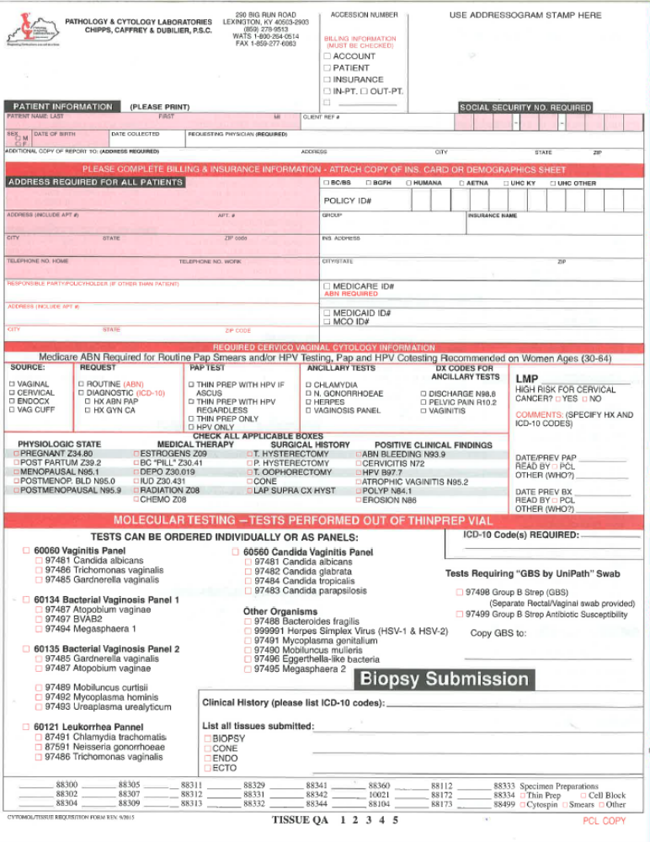
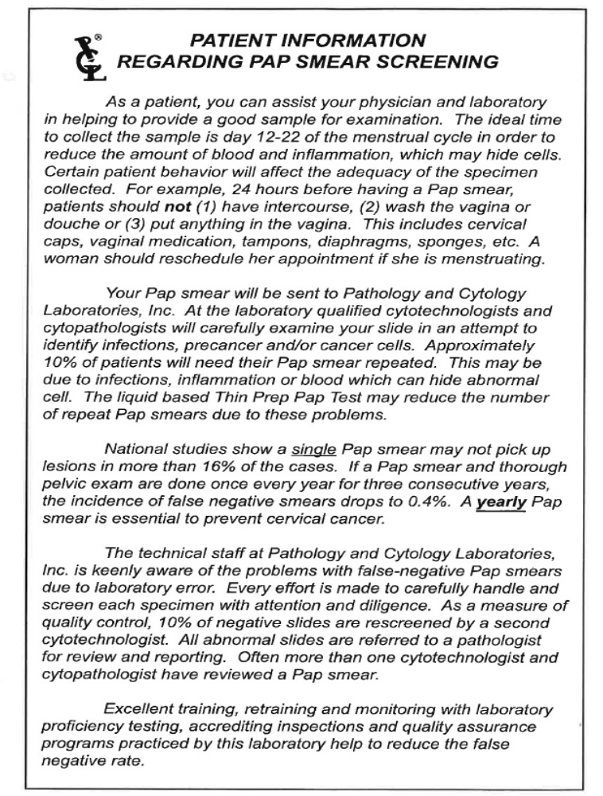

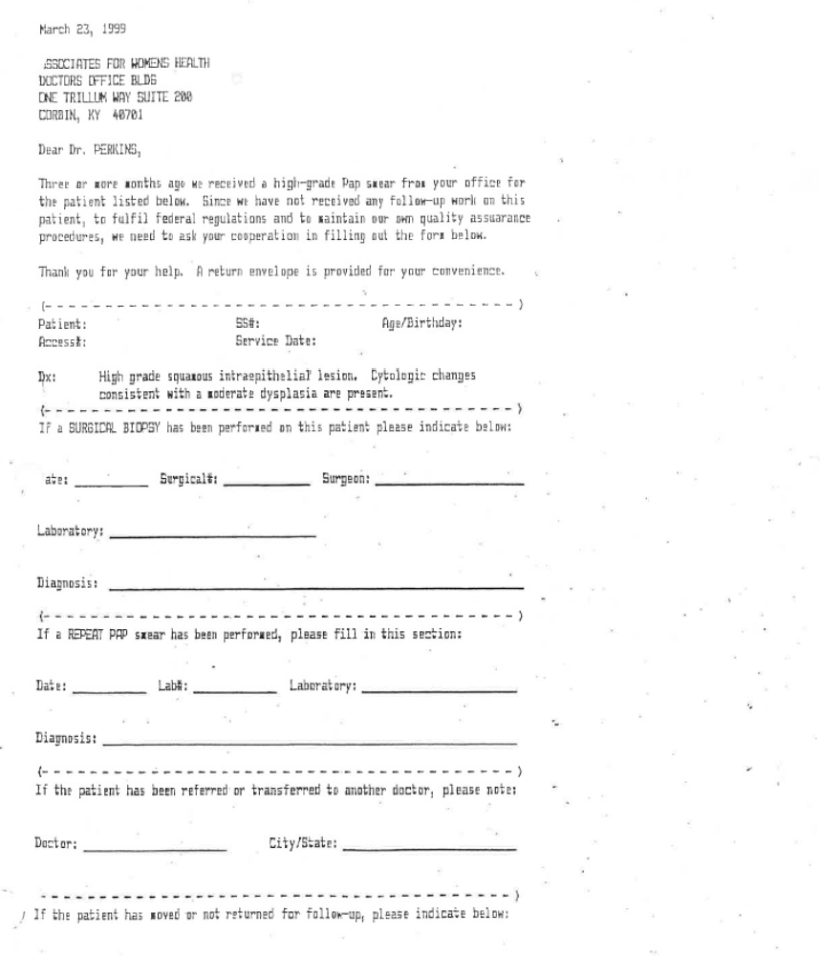

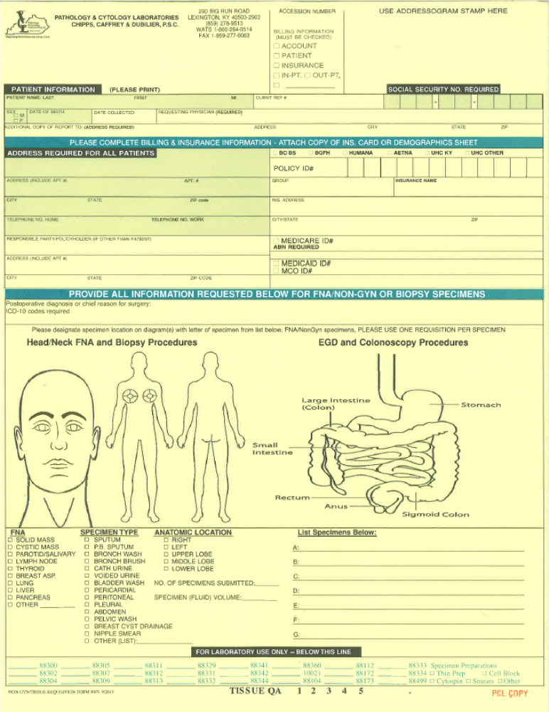
FROZEN SECTION CONSULTATION

- The white copy of the Frozen Section Form should be retained in the patient file.
- The yellow copy should be kept with the frozen tissue.
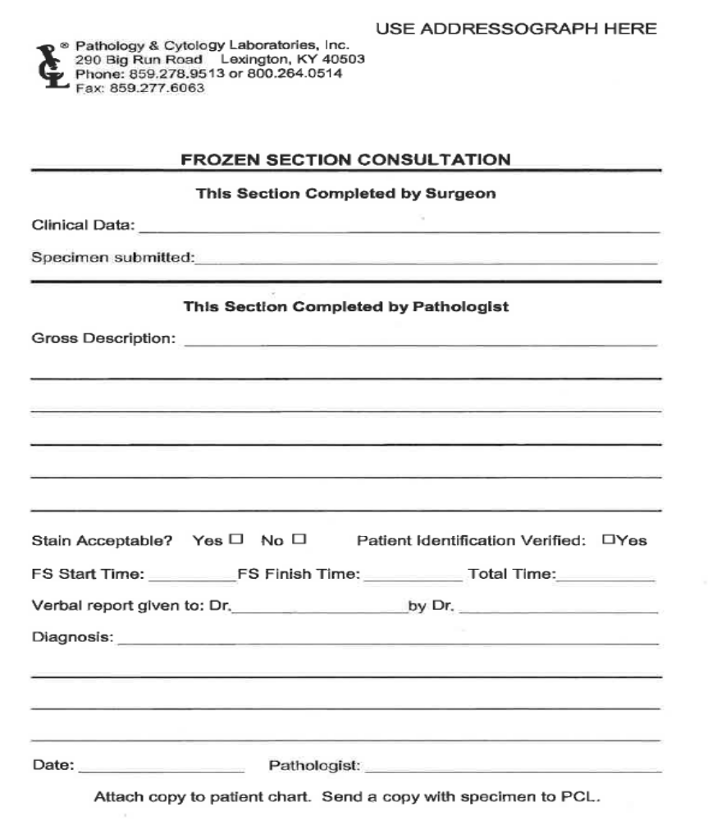
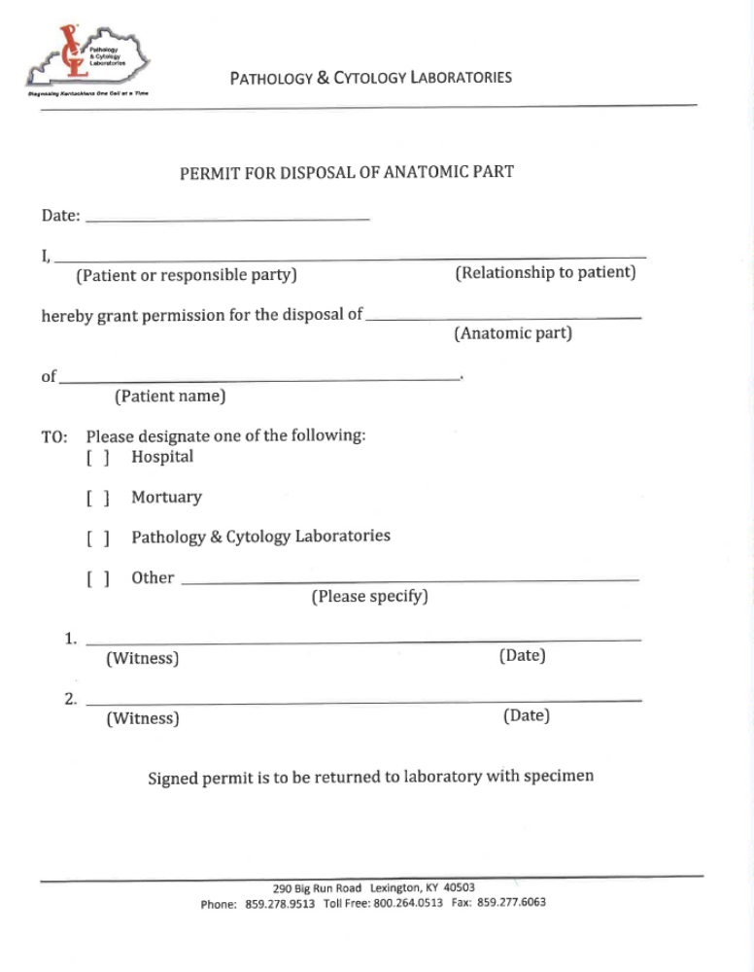

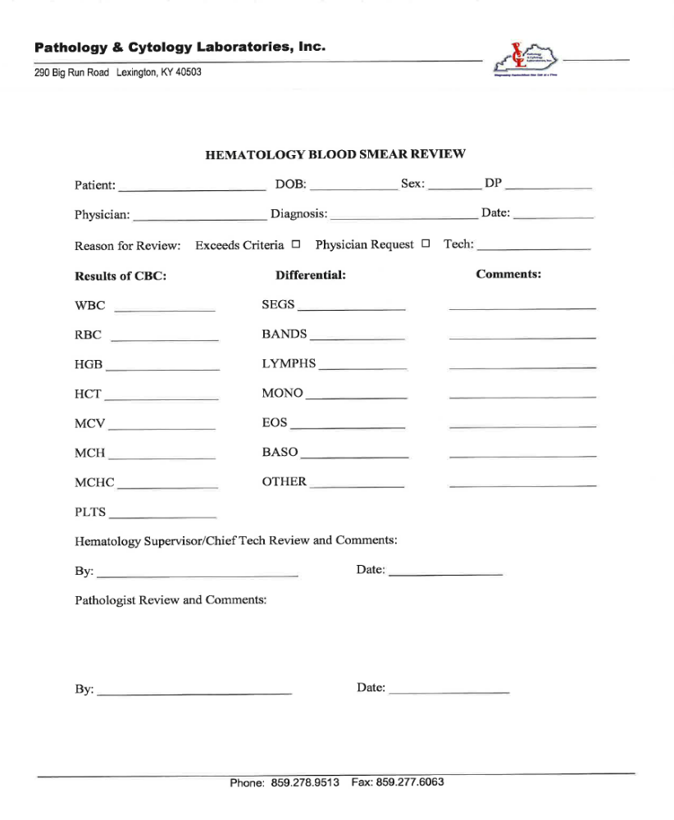

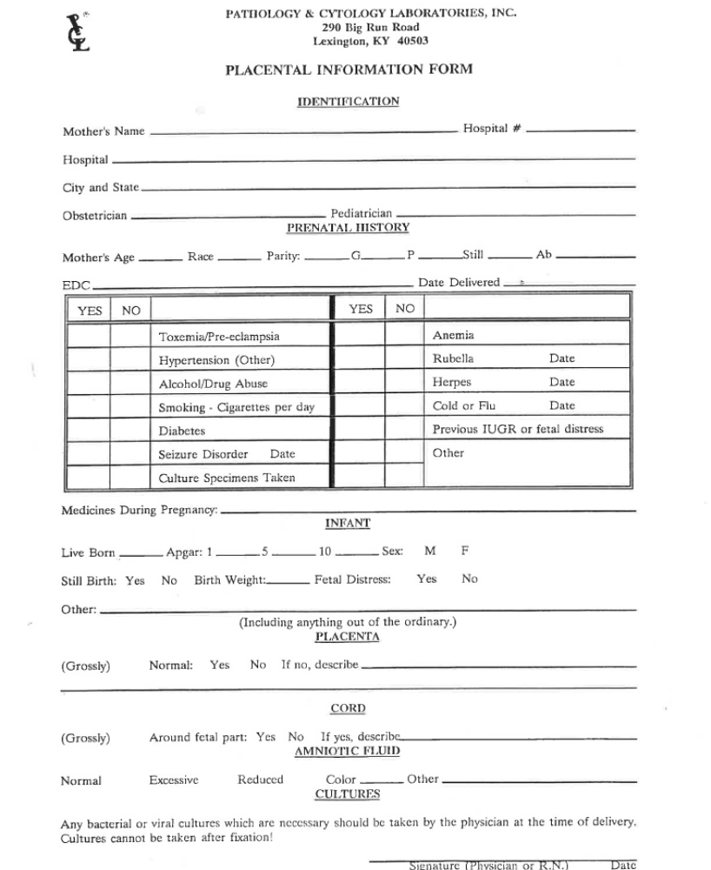

Department of Pathology & Laboratory Medicine Special Procedures Laboratory Louisville, KY 40202 PROTOCOL FOR MUSCLE & NERVE BIOPSIES

The Department of Pathology at the University of Louisville, in Louisville, Kentucky, currently offers histochemical evaluation of muscle biopsy specimens and electron microscopic evaluation, if indicated. Proper handling of the muscle biopsy, especially proper freezing, will help ensure a correct diagnosis for the patient; therefore, the following protocol should be observed. Due to the limitations of our laboratory, we DO NOT accept fresh specimens containing INFECTIOUS AGENTS: such as, but not limited to, hepatitis, human immunodeficiency virus (HIV), tuberculosis (TB), or Creutzfeldt-Jakob disease (CJD). MUSCLE BIOPSY

1. SCHEDULING - Notify the Special Procedures Laboratory (SPL), (502) 852-5519, 24 hours in advance of the biopsy. It is the responsibility of the surgeon or his office, the surgery department where the biopsy is being performed, and the submitting Pathology Laboratory to see that the muscle biopsy is scheduled with SPL.
2. TRANSPORTATION - The courier from the UofL Pathology Department will pick up muscle biopsies from the hospitals within the Medical Center complex. All other hospitals should send the specimen, on wet ice, via a local courier. ALL SPECIMENS MUST BE LABELED WITH THE BIOHAZARD LABEL AS PER THE KENTUCKY BLOODBORNE PATHOGENS STANDARD #1910.1030. ALL SPECIMENS MUST BE LABELED WITH THE PATHOLOGY ACCESSION NUMBER.
3. AVAILABLE - Biopsies may be scheduled between 8:00AM and 2:00 PM, Monday through Friday, excluding holidays. To properly handle 'emergency' or otherwise unscheduled biopsies, please contact SPL.
4. MUSCLE - The biopsy specimen for frozen section enzyme histochemistry should be UNCLAMPED and UNDAMAGED (e.g., tied to tongue blades or squeezed with forceps,), UNCAUTERIZED, NOT PREVIOUSLY DISSECTED, and NOT CHOPPED. It should be placed on gauze that has been slightly dampened with saline. A muscle biopsy 7-10 mm in diameter is optimal, comparable to a pencil eraser. DO NOT place muscle, at any time, in or near any gross area containing the liquid or fumes of formalin, glutaraldehyde, or alcohols as these will alter the enzymes.
5. PATIENT INFORMATION – As required by the College of American Pathologists (CAP), specimens must be accompanied with a completed requisition form, which includes patient identification, hospital numbers, pathology accession number, appropriate clinical information, and patient history. Billing and insurance information is also necessary.
7. CANCELATION – Should a scheduled muscle biopsy be canceled, please notify SPL as soon as possible. 8. STAINS - The stains routinely performed for diagnosis include: H&E, modified Gomori trichrome, oil red O, Congo red, PAS, PAS-D, ATPase (4.3, 9.4), SDH, NADH, COX, PFK, NE, APP, MPP, and AD.
9. SNAP FREEZE - Specimen will be frozen and stored at -70 °C according to CAP guidelines.

10. REPORT - In general, a verbal or written report will be available within 4 working days of receipt of the specimen.
OTHER INFORMATION 1. Indications for muscle biopsy a. Unexplained muscle weakness. b. Unexplained muscle pain. c. Evaluation of connective tissue disorder. d. Abnormality of muscle contraction such as myotonia or hypotonia. 2. Before biopsy - Before a muscle biopsy, certain points should be considered. The muscle selected for biopsy should be the least affected but definitely affected. Severely fibrotic or atrophic muscle should be avoided. Sites which have been previously traumatized by biopsy, injection, electromyography, or trauma should be avoided. Determine if muscle is to be obtained for special enzyme histochemistry studies, biochemical analysis, electron microscopy, routine paraffin processing, all of these, or any combination of these.

NERVE BIOPSY 1. Nerve biopsies should contain the same information/paperwork as muscle biopsies. 2. Nerve biopsies are to be sent fresh on barely moistened saline gauze. 3. Stains include: H&E, Masson trichrome, LFB/PAS, Congo red, and neurofilament via immunohistochemistry. 4. Electron microscopy with toluidine blue thick-sections will be performed.

SEE WEBSITES BELOW FOR OTHER FACILITIES:

https://www/aruplab.com/files/resources/testing/MuscleandNerveTransportKit.pdf
https://www.mayocliniclabs.com/test-catalog/Overview /70594
https://clevelandcliniclabs.com/wp-content/assets/pdfs/forms/submitting-muscle-biopsy-specimens.pdf

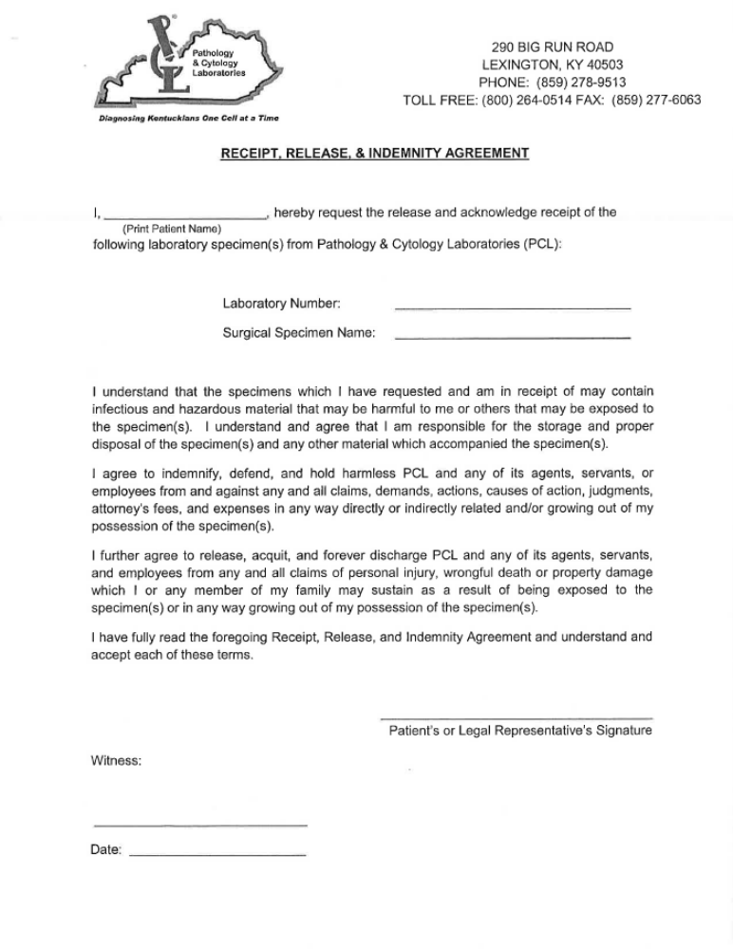
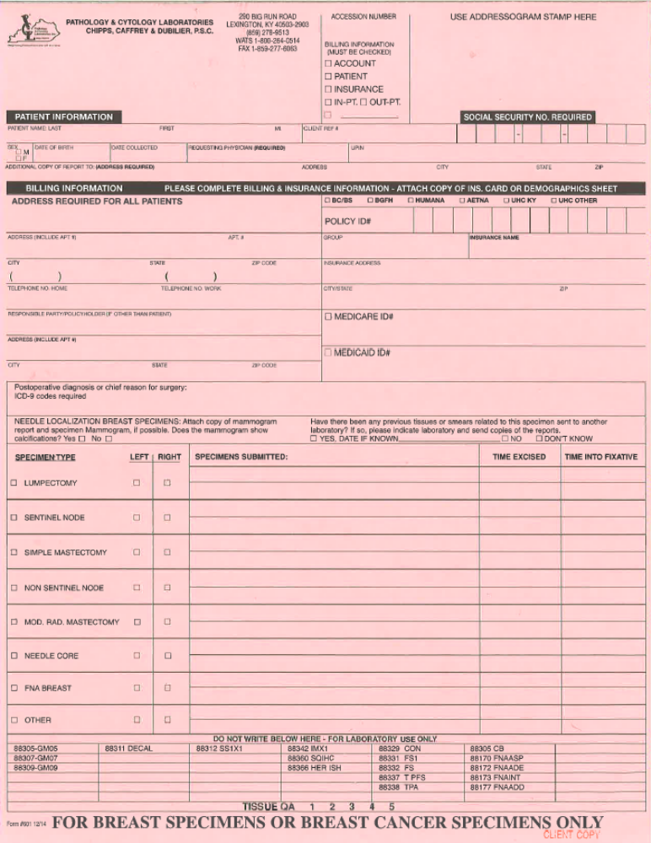

M S D S


